Below is suggested social copy (image options attached) to help you promote this month’s health and wellness topic – Mindfulness and Movement – among your members. Feel free to share on your internal communication platforms and via your own LinkedIn accounts, as appropriate.

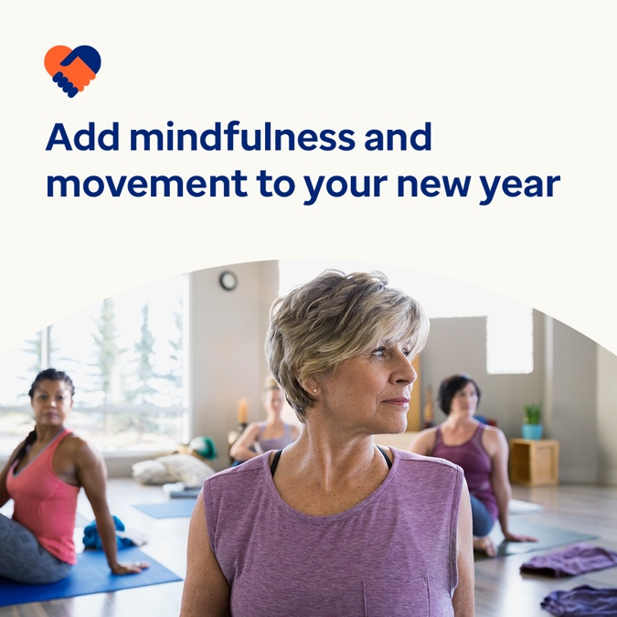 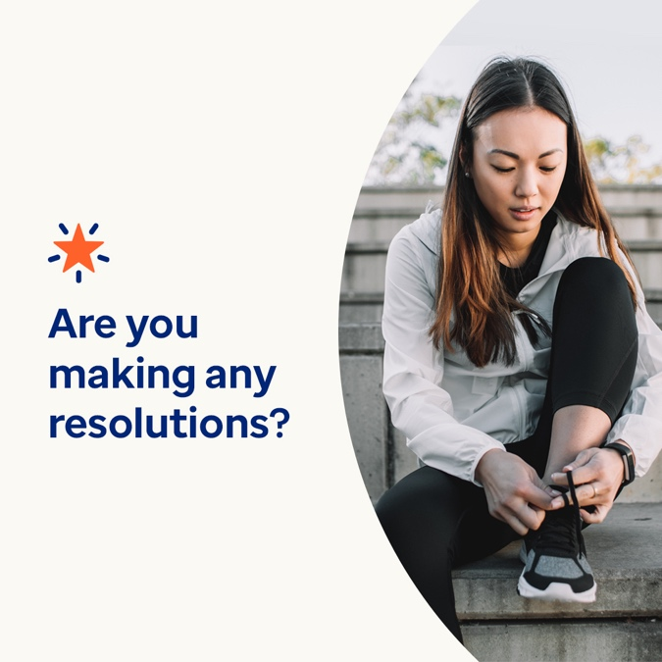

**Mindfulness and Movement**

Option 1

New Year’s resolutions often focus on improving your physical health but let’s remember mental health plays a huge role in how our bodies feel. This month, learn more about why mindfulness and movement are so important for your well-being, and how to incorporate both more into your life. Visit optumeap.com/newthismonth

#employeehealth #wellbeing

Option 2

Looking for a great way to help set the New Year up for success? Consider focusing more on your health and wellbeing, starting with the mind-body connection. This month’s Engagement Toolkit offers tips for mindfulness and movement. Learn more here: Visit optumeap.com/newthismonth.

#employeehealth #wellbeing

Option 3 – an option to promote the new format with your members

New Year, new way to connect with your employees! Our new monthly engagement toolkits offer enriching multimedia content on relevant topics and trends. This month features quick-hit tips for mindfulness and movement – and is now live! Visit optumeap.com/newthismonth

#employeehealth #wellbeing

Posting instructions

**How to post on LinkedIn:**

* Open your LinkedIn account
* Select your preferred text (including link) from above. Copy + paste
* Choose your preferred image and add to your post (save image to your drive, select “add photo” prior to step 4
* Click “post”