Below is suggested social media copy (image options attached) to help you promote this month’s health and wellness topic – Suicide Prevention and Recovery – among your members. Please feel free to share this on your internal communication platforms and via your LinkedIn accounts, as appropriate.

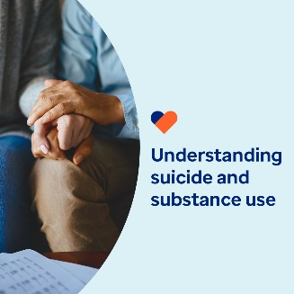 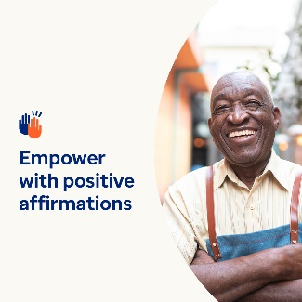 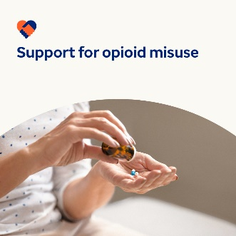 

* Suicide and substance use disorders are more common than most people think. This month’s tool kit explores these topics and provides resources and tools to support you and the people close to you. [optumwellbeing.com/newthismonth/en-GB](https://optumwellbeing.com/newthismonth/en-GB) #employeehealth #wellbeing
* Practising positive affirmations encourages us to focus on our strengths and potential. Check out this month’s interactive guide to creating your own simple, yet powerful, statements to reinforce your mental health and wellbeing. [optumwellbeing.com/newthismonth/en-GB](https://optumwellbeing.com/newthismonth/en-GB) #employeehealth #wellbeing
* Opioid use and misuse are on the rise around the world. Learn more about why, who’s at risk, and how to help support prevention and treatment efforts in this month’s tool kit. [optumwellbeing.com/newthismonth/en-GB](https://optumwellbeing.com/newthismonth/en-GB) #employeehealth #wellbeing
* Even your strong friends might need support. Learn more about why it’s important to check in on them and how to recognise signs that they may be masking emotional pain in this month’s tool kit. [optumwellbeing.com/newthismonth/en-GB](https://optumwellbeing.com/newthismonth/en-GB) #employeehealth #wellbeing

**How to post on LinkedIn:**

* Open your LinkedIn account
* Select your preferred text (including link) from above. Copy + Paste
* Choose your preferred image and add it to your post (save the image to your drive, select ‘Add photo’ prior to step 4)
* Click ‘Post’