Below is suggested social media copy (image options attached) to help you promote this month’s health and wellness topic — suicide prevention and recovery — amongst your members. Please feel free to share this on your internal communication platforms and via your own LinkedIn accounts, as appropriate.

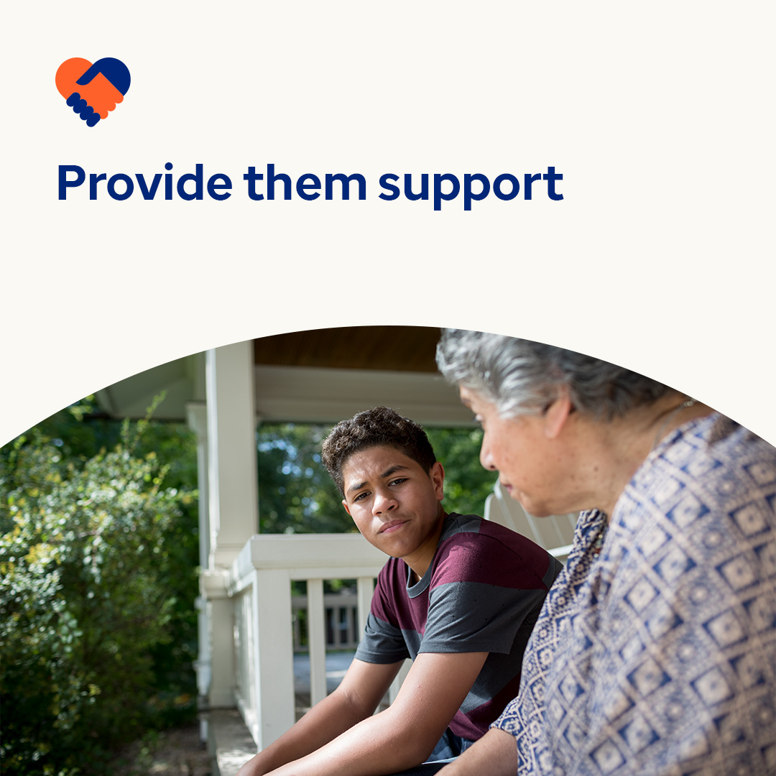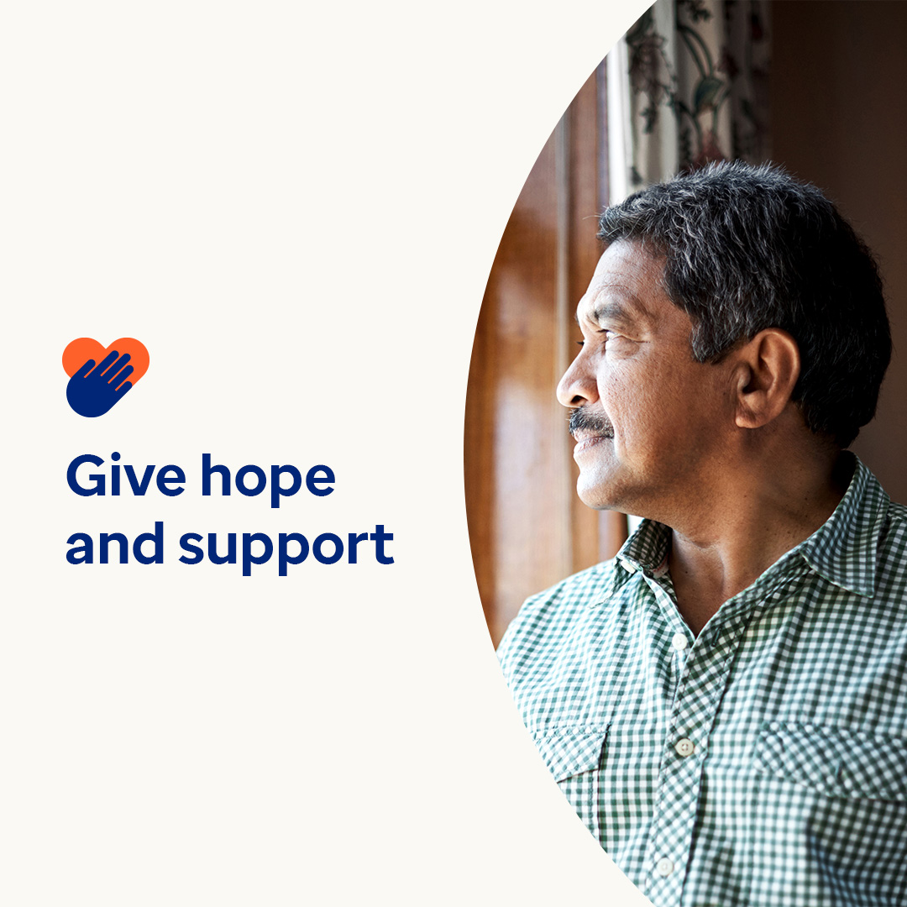

* Suicide and substance abuse disorders are difficult topics. But even in the toughest times and situations, there is certainly reason to hope. Suicide is preventable. And substance abuse disorders are treatable. Millions of people around the world live healthily in recovery. This month, learn more about the signs and symptoms of mental health and substance abuse disorders and how to nurture hope. optumwellbeing.com/newthismonth/en-GB #employeehealth #wellbeing
* Is someone you care about misusing drugs or alcohol? Have a look at this guide for spotting the signs of a substance abuse disorder, providing support and talking to teenagers about the dangers of misuse. optumwellbeing.com/newthismonth/en-GB #employeehealth #wellbeing
* Scientific research shows that people who think positively tend to live longer, healthier lives. Use the interactive self-care worksheet to nurture your optimism and hope! optumwellbeing.com/newthismonth/en-GB #employeehealth #wellbeing
* **Creating hope through action** — 10 September is World Suicide Prevention Day. We can all do our bit to help reduce the stigma around suicide and encourage people to seek the care they may need. There is hope. #WorldSuicidePreventionDay optumwellbeing.com/newthismonth/en-GB #employeehealth #wellbeing
* People struggling with suicidal thoughts need support — and hope. We can all help them feel confident that there is an alternative to suicide by doing what we can to raise awareness of mental health conditions and encouraging people to seek the support they may need. #WorldSuicidePreventionDay optumwellbeing.com/newthismonth/en-GB #employeehealth #wellbeing

**How to post on LinkedIn:**

* Open your LinkedIn account
* Select your preferred text (including link) from above. Copy + paste
* Choose your preferred image and add it to your post (save the image to your drive, select ‘Add photo’ prior to step 4)
* Click ‘Post’