Below is suggested social media copy (image options attached) to help you promote this month’s health and wellness topic – Managing Stress – among your members. Please feel free to share this on your internal communication platforms and via your own LinkedIn accounts, as appropriate.

   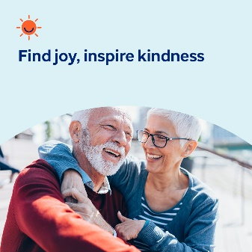

* The 10th of October is World Mental Health Day. Take a moment to learn more about mental health and wellbeing – and how you can help nurture your own mental health and prevent stigma. [optumwellbeing.com/newthismonth/en-GB](https://optumwellbeing.com/newthismonth/en-GB) #employeehealth #wellbeing #WorldMentalHealthDay
* Many children and adolescents experience bullying — whether as the victim, the bully or both. Learn more about what motivates bullies and how to prevent them in this month’s toolkit. [optumwellbeing.com/newthismonth/en-GB](https://optumwellbeing.com/newthismonth/en-GB) #employeehealth #wellbeing #WorldMentalHealthDay
* Get tips for being the kind of father you hope to be in this month’s toolkit. [optumwellbeing.com/newthismonth/en-GB](https://optumwellbeing.com/newthismonth/en-GB) #employeehealth #wellbeing #WorldMentalHealthDay
* Here’s a simple way to take note of the good in you, your life and self-worth, so that you can inspire others to do the same. [optumwellbeing.com/newthismonth/en-GB](https://optumwellbeing.com/newthismonth/en-GB) #employeehealth #wellbeing #WorldMentalHealthDay

**How to post on LinkedIn:**

* Open your LinkedIn account
* Select your preferred text (including link) from above. Copy + Paste
* Choose your preferred image and add it to your post (save the image to your drive, select ‘Add photo’ prior to step 4)
* Click ‘Post’