Below is suggested social media copy (image options attached) to help you promote this month’s health and wellness topic – World Mental Health – among your members. Feel free to share on your internal communication platforms and via your own LinkedIn accounts, as appropriate.

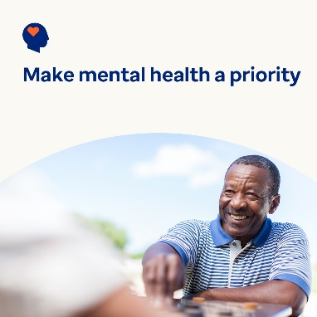 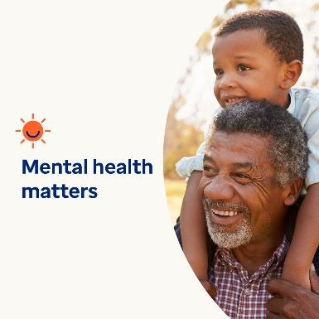 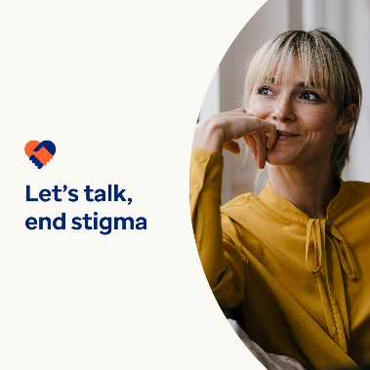

* October 10 is World Mental Health Day. Mental health is just as important as physical health. And they’re both equally important to your overall health and wellness. This month, let’s look at ways to stop stigma, so more people feel safe and comfortable asking for help. optumwellbeing.com/newthismonth #employeehealth #wellbeing #WorldMentalHealthDay
* Despite how common mental health concerns and conditions are, stigma persists and keeps people from seeking help. Check out tips on how you can help stop stigma, so people feel safer and more comfortable getting the help they need. optumwellbeing.com/newthismonth #employeehealth #wellbeing
* October 10 is World Mental Health Day. Learn more about what mental health is, why it matters, how to talk about it and why overcoming stigma is important. optumwellbeing.com/newthismonth #employeehealth #wellbeing #WorldMentalHealthDay
* October 10 is World Mental Health Day. How much do you know about mental health conditions? Take this month’s true-or-false quiz to find out. optumwellbeing.com/newthismonth #employeehealth #wellbeing #WorldMentalHealthDay

**How to post on LinkedIn:**

* Open your LinkedIn account
* Select your preferred text (including link) from above. Copy + paste
* Choose your preferred image and add to your post (save image to your drive, select “add photo” prior to step 4
* Click “post”