Below is suggested social media copy (image options attached) to help you promote this month’s health and wellness topic – Gratitude – amongst your members. Please feel free to share this on your internal communication platforms and via your own LinkedIn accounts, as appropriate.

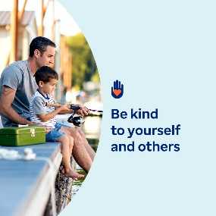 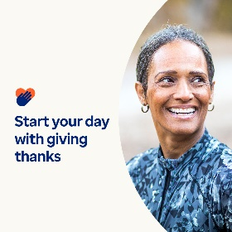 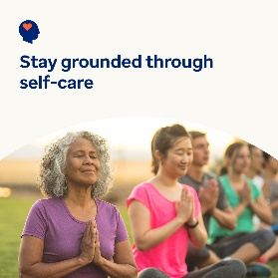 

* The 13th of November is World Kindness Day. Learn the many benefits of kindness for yourself and others in this month’s toolkit. [optumwellbeing.com/newthismonth/en-GB](https://optumwellbeing.com/newthismonth/en-GB) #employeehealth #wellbeing #WorldKindnessDay #SpreadKindness
* Take the gratitude challenge: 30 ways to be kind to yourself for 30 days! [optumwellbeing.com/newthismonth/en-GB](https://optumwellbeing.com/newthismonth/en-GB) #employeehealth #wellbeing #WorldKindnessDay #SpreadKindness
* Learn why processing your emotions is crucial for your mental wellbeing, how to check in with yourself and how to perform self-care to stay on top of your feelings. [optumwellbeing.com/newthismonth/en-GB](https://optumwellbeing.com/newthismonth/en-GB) #employeehealth #wellbeing #wellbeing #WorldKindnessDay #SpreadKindness
* Here’s a kind way to brighten someone’s day! #employeehealth [optumwellbeing.com/newthismonth/en-GB](https://optumwellbeing.com/newthismonth/en-GB) #employeehealth #wellbeing #wellbeing #WorldKindnessDay #SpreadKindness

**How to post on LinkedIn:**

1. Open your LinkedIn account
2. Select your preferred text (including link) from above and copy + paste
3. Choose your preferred image and add it to your post (save the image to your drive, select ‘Add photo’ prior to step 4)
4. Click ‘Post’