Below is suggested social media copy (image options attached) to help you promote this month’s health and wellness topic — Kindness and gratitude — among your members. Feel free to share on your internal communication platforms and via your own LinkedIn accounts, as appropriate.

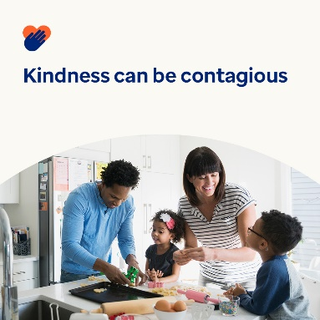 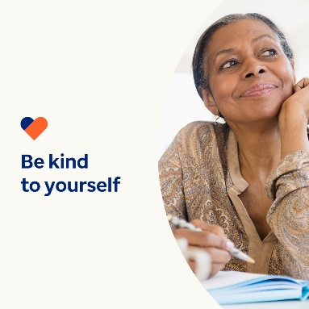 

* November 13 is World Kindness Health Day. Research shows being kind boosts your mental and emotional health. It also shows kindness can be contagious. This month, learn tips and tools for spreading kindness. optumwellbeing.com/newthismonth #employeehealth #wellbeing #WorldKindnessDay
* An important part of being kind is being kind to yourself. Listen to this month’s podcast on “Journaling for Self-Compassion,” then download the worksheet to get your kindness journal started. optumwellbeing.com/newthismonth #employeehealth #wellbeing #WorldKindnessDay
* To help spread kindness, check out these 7 tips for easy ways to make someone’s day. optumwellbeing.com/newthismonth #employeehealth #wellbeing #WorldKindnessDay

**How to post on LinkedIn:**

* Open your LinkedIn account
* Select your preferred text (including link) from above. Copy + paste
* Choose your preferred image and add to your post (save image to your drive, select “add photo” prior to step 4
* Click “post”