Shown below is some suggested social media copy (image options also attached) to help you with promoting this month’s health and wellness topic — Kindness and gratitude — among your members. Feel free to share this on your internal communication platforms and via your own LinkedIn accounts, as appropriate.

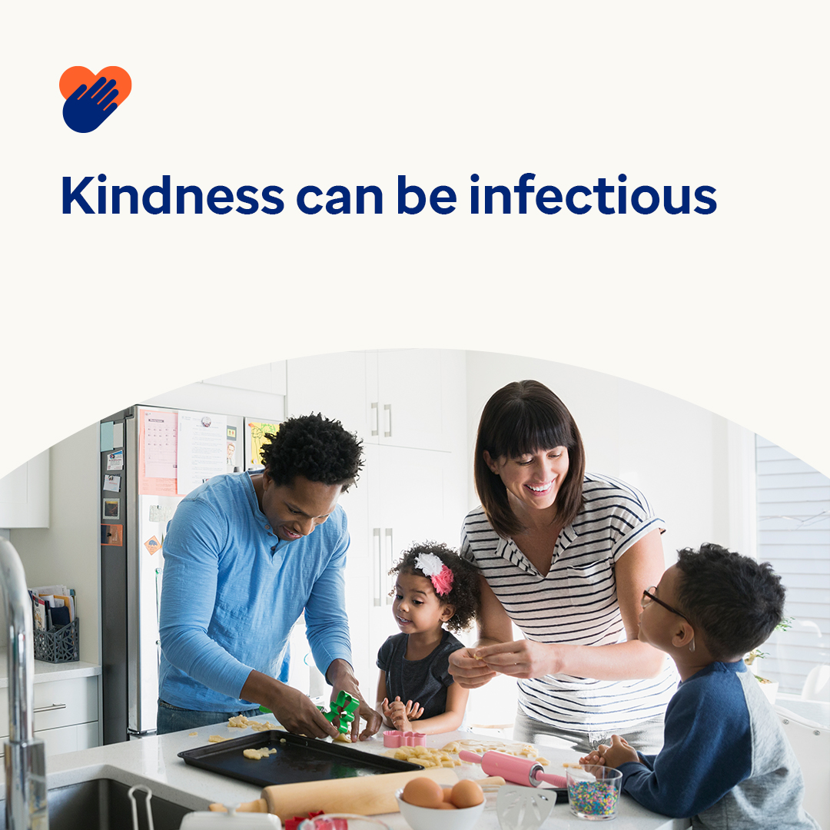 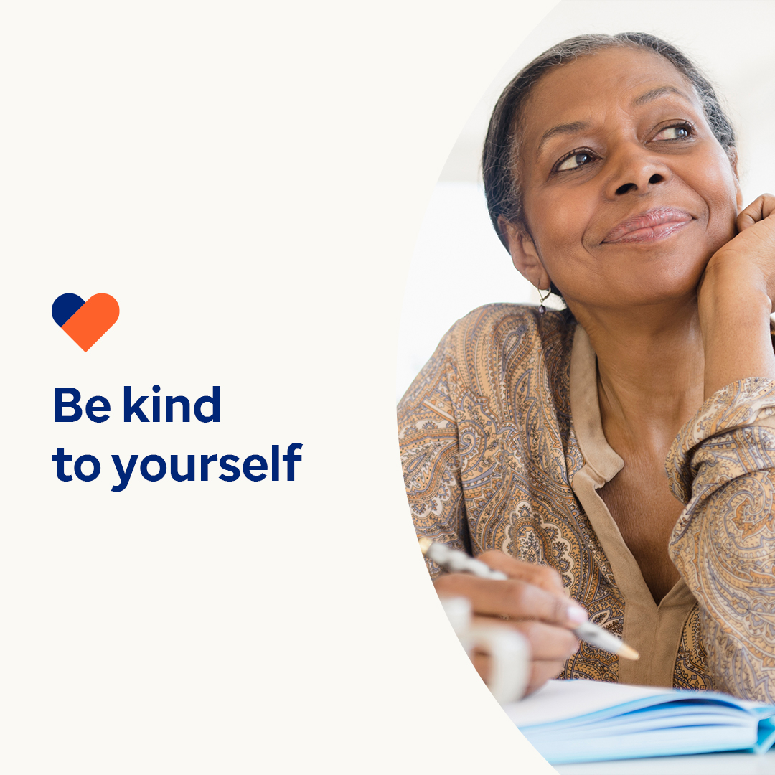 

* 13th November is World Kindness Day. Research shows that being kind boosts your mental and emotional health. It also shows that kindness can be infectious. This month, you can learn some tips and tools for spreading kindness. optumwellbeing.com/newthismonth/en-GB #employeehealth #wellbeing #WorldKindnessDay
* An important part of being kind is being kind to yourself. Listen to this month’s podcast on ‘Journalling for Self-Compassion’ then download the worksheet to get your kindness journal started. optumwellbeing.com/newthismonth/en-GB #employeehealth #wellbeing #WorldKindnessDay
* To help spread kindness, check out these 7 tips for easy ways to make someone’s day. optumwellbeing.com/newthismonth/en-GB #employeehealth #wellbeing #WorldKindnessDay

**How to post on LinkedIn:**

* Open your LinkedIn account
* Select your preferred text (including link) from above. Copy + Paste
* Choose your preferred image and add it to your post (save the image to your drive, select ‘Add photo’ prior to step 4)
* Click ‘Post’