Below is suggested social media copy (image options attached) to help you promote this month’s health and wellness topic – Mental Health Awareness – amongst your members. Please feel free to share this on your internal communication platforms and via your own LinkedIn accounts, as appropriate.

  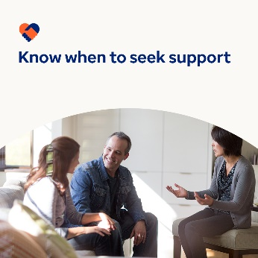 

* This month’s toolkit is about turning mental health awareness into action. Explore resources, strategies and steps that you can take to manage feelings, thoughts and behaviours, and improve your overall wellbeing. [optumwellbeing.com/newthismonth/en-GB](https://optumwellbeing.com/newthismonth/en-GB)  
  #employeehealth #wellbeing #mentalhealthawareness
* Being more mindful in your everyday life can help bring you calm and joy. Here are some practical ways to do so. [optumwellbeing.com/newthismonth/en-GB](https://optumwellbeing.com/newthismonth/en-GB)  
  #employeehealth #wellbeing #mentalhealthawareness
* Have you ever thought about seeing a therapist but weren’t sure where to start? This month’s toolkit includes a podcast and article with tips for knowing when to seek support and finding a therapist that’s right for you. [optumwellbeing.com/newthismonth/en-GB](https://optumwellbeing.com/newthismonth/en-GB) #employeehealth #wellbeing #mentalhealthawareness
* Setting healthy personal boundaries is an important way of taking care of yourself. You can use the worksheet in this month’s toolkit to identify and set boundaries to nurture your mental health and wellbeing. [optumwellbeing.com/newthismonth/en-GB](https://optumwellbeing.com/newthismonth/en-GB) #employeehealth #wellbeing #mentalhealthawareness

**How to post on LinkedIn:**

* Open your LinkedIn account
* Select your preferred text (including link) from above. Copy + Paste
* Choose your preferred image and add it to your post (save the image to your drive, select ‘Add photo’ prior to step 4)
* Click ‘Post’