Below is suggested social media copy (image options attached) to help you promote this month’s health and wellness topic — Mental Health Awareness — among your members. Please feel free to share this on your internal communication platforms and via your own LinkedIn accounts, as appropriate.

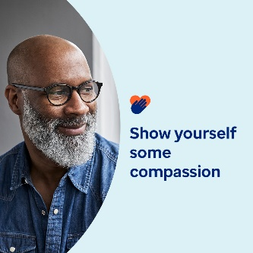 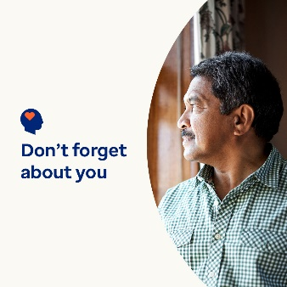 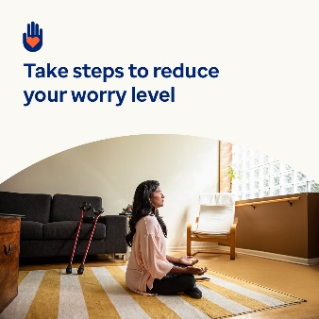 

* Being a caregiver is a big responsibility. But it’s crucial to take care of yourself too. In this month’s toolkit, you’ll find resources, tips and tools for self-care and showing yourself compassion. [optumwellbeing.com/newthismonth/en-GB](https://optumwellbeing.com/newthismonth/en-GB) #employeehealth #wellbeing
* Are you a ‘sandwich generation’ caregiver? Learn how and why you should show yourself more compassion. [optumwellbeing.com/newthismonth/en-GB](https://optumwellbeing.com/newthismonth/en-GB) #employeehealth #wellbeing
* Do you waste time at the weekend worrying about the working week? Try this activity for turning those thoughts around. [optumwellbeing.com/newthismonth/en-GB](https://optumwellbeing.com/newthismonth/en-GB) #employeehealth #wellbeing
* Get tips on finding a therapist that’s right for you. [optumwellbeing.com/newthismonth/en-GB](https://optumwellbeing.com/newthismonth/en-GB) #employeehealth #wellbeing #worldhealthday

**How to post on LinkedIn:**

* Open your LinkedIn account
* Select your preferred text (including link) from above. Copy + Paste
* Choose your preferred image and add it to your post (save the image to your drive, select ‘Add photo’ prior to step 4)
* Click ‘Post’