Below is suggested social media copy (image options attached) to help you promote this month’s health and wellness topic — Mental Health Awareness — among your members. Feel free to share on your internal communication platforms and via your own LinkedIn accounts, as appropriate.

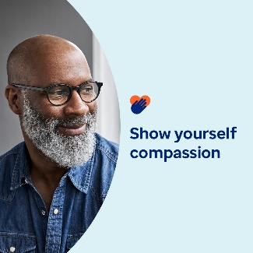 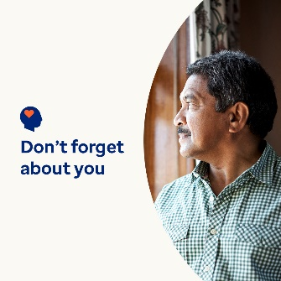 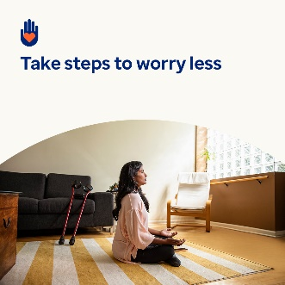 

* Being a caregiver is a big responsibility. But it’s crucial to take care of yourself, too. In this month’s toolkit, find resources, tips and tools for self-care and showing yourself compassion. [optumwellbeing.com/newthismonth/en-US](https://optumwellbeing.com/newthismonth/en-US) #employeehealth #wellbeing
* Are you a “sandwich generation” caregiver? Learn how and why you should show yourself more compassion. [optumwellbeing.com/newthismonth/en-US](https://optumwellbeing.com/newthismonth/en-US) #employeehealth #wellbeing
* Do you waste time on the weekend worrying about the workweek? Try this activity for turning those thoughts around. [optumwellbeing.com/newthismonth/en-US](https://optumwellbeing.com/newthismonth/en-US) #employeehealth #wellbeing
* Get tips for finding a therapist that’s right for you. [optumwellbeing.com/newthismonth/en-US](https://optumwellbeing.com/newthismonth/en-US) #employeehealth #wellbeing #worldhealthday

**How to post on LinkedIn:**

* Open your LinkedIn account
* Select your preferred text (including link) from above. Copy + paste
* Choose your preferred image and add to your post (save image to your drive, select “add photo” prior to step 4
* Click “post”