Below is suggested social media copy (image options attached) to help you promote this month’s health and wellness topic – Calming Anxiety – among your members. Feel free to share this on your internal communication platforms and via your own LinkedIn accounts, as appropriate.

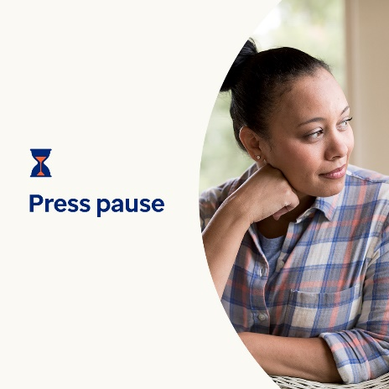  

* Everyone faces stress and worries. But are anxiety, stress and worry hurting your quality of life? Learn the signs and coping strategies. Optumeap.com/newthismonth/en-GB #employeehealth #wellbeing
* Has your mind been racing lately? Are you worrying more often than not? Do you feel overwhelmed? If you answered yes, take a moment to reflect on your thoughts. Press pause on the day’s to-do list and go for a walk or try positive self-talk. Learn more coping strategies here. Optumeap.com/newthismonth/en-GB #employeehealth #wellbeing
* Worrying and feeling stressed can be a normal part of living life. But ongoing worries can interfere with your life. Learn how to tell the difference and what you can do to help yourself cope. Optumeap.com/newthismonth/en-GB #employeehealth #wellbeing

**How to post on LinkedIn:**

* Open your LinkedIn account
* Select your preferred text (including link) from above. Copy + paste
* Choose your preferred image and add it to your post (save image to your drive, select “add photo” prior to step 4
* Click “post”