During moments of stress or anxious thoughts, sometimes it helps to have a physical reminder to pause and feel moments of calm in your day-to-day life. That’s why we have created a repositionable, textured sticker design and made it available to order for your organisation during the month of May. Order it and provide your organisation with a unique reminder to take time to step away from the stressors of the day and focus on finding some calm.

**Sticker: Trace each colour circle (Optum branded)**

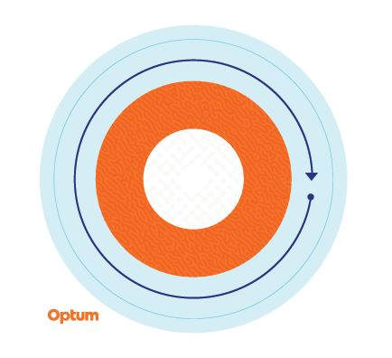

Starting on the outer ring and working your way inwards, slowly trace each colour on the sticker, noticing the changes in texture, and breathe deeply. Repeat as many times as necessary.

The sticker is made from repositionable vinyl and can be stuck onto water bottles, laptops, desks and more. It can be transferred to different surfaces to find the place that you like best.

Stickers are available in packs of 100. Please order for roughly 10% of your onsite population or a maximum quantity per client of 2,000 stickers, whichever number is the smaller. Limited quantities are available, and orders are on a first-come, first-served basis. Stickers are despatched to a single location**. To request an order for stickers, please contact your account management team with the quantity you would like to order, your delivery address, contact name and phone number.**

These stickers are recommended to be used as a self-help coping tool for periodic stress and anxious thoughts, and are not intended as a substitute for clinical intervention. If you are experiencing persistent stress and/or anxious thoughts and are unable to manage these feelings, consult a medical or mental health professional for help.