During moments of stress or anxious thoughts, sometimes it helps to have a physical reminder to pause and feel moments of calm in your day-to-day life. That’s why we have created two repositionable, textured sticker designs and made them available to order for your organization during the month of May. Choose one or both designs and provide your organization with a unique reminder to take time to step away from the stressors of the day and focus on finding some calm.
Sticker option 1: Trace each color circle (Optum branded)
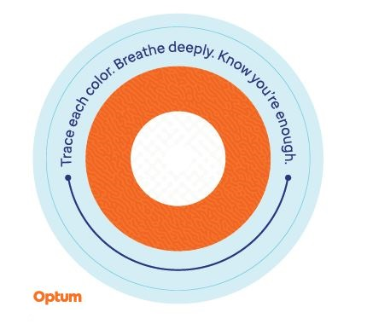
Starting on the outer ring and working your way inward, slowly trace each color on the sticker, noticing the changes in texture and breathe deeply. Repeat as many times as necessary.

Sticker option 2: 4-7-8 breathing
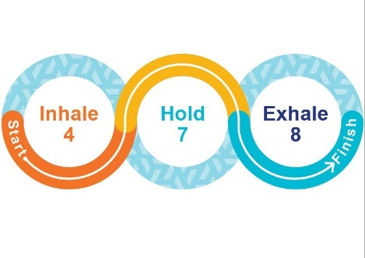
Place your finger at the indicated starting point. As you slowly move your finger along the directional line, inhale to a count of 4, then hold your breath for a count of 7 and exhale for a count of 8. Notice the change in texture as you go. Repeat as many times as necessary.

Stickers are made from repositionable vinyl and can be adhered to water bottles, laptops, desks, and more. They can be transferred to different surfaces to find the place that you like best.
Stickers are available in packs of 100. Please order roughly 10% of your onsite population or a maximum quantity per client of 2,000 stickers, whichever number is less. You can choose to order 1 sticker or both. If you choose to order both, the maximum quantity ordered cannot surpass 2,000 total. Limited quantities are available, and orders are on a first come, first serve basis. Stickers are shipped to a single location.
To request an order of stickers, please reach out to your account management team with the quantity you would like to order, shipping address, contact name and phone number.
Stickers can be paired with the instructional handout available to download as part of the May toolkit.

These stickers are recommended to be used as a self-help coping tool for periodic stress and anxious thoughts and are not intended to replace clinical intervention. If you are experiencing persistent stress and/or anxious thoughts and are unable to manage these feelings, consult with a medical or mental health professional for help.

