**Member resources:  
Calming anxiety**

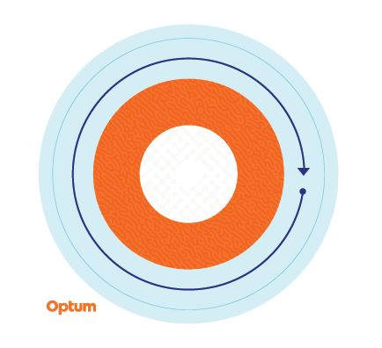

**Sensory sticker**

**Sticker to help feel moments of calm**

During moments of stress or anxious thoughts, sometimes it helps to have a physical reminder to pause and feel moments of calm in your day-to-day life. That’s why we have created a repositionable, textured sticker to take time to step away from the stressors of the day and focus on finding some calm.

Starting on the outer ring and working your way inward, slowly trace each colour on the sticker, noticing the changes in texture, and breathe deeply. Repeat as many times as necessary.

These stickers are recommended to be used as a self-help coping tool for periodic stress and anxious thoughts, and are not intended to replace clinical intervention. If you are experiencing persistent stress and/or anxious thoughts and are unable to manage these feelings, consult a medical or mental health professional for help.

This programme should not be used for emergency or urgent care needs. In an emergency, call 911 if you are in the United States or the local emergency services phone number if you are outside the United States, or go to the nearest accident & emergency department. This programme is not a substitute for a doctor’s or professional’s care. Due to the potential for a conflict of interest, legal consultation will not be provided on issues that may involve legal action against Optum or its affiliates, or any entity through which the caller is receiving these services directly or indirectly (e.g. employer or health plan). This programme and all its components, in particular services to family members below the age of 16, may not be available in all locations and are subject to change without prior notice. Experience and/or educational levels of Employee Assistance Programme resources may vary based on contract requirements or country regulatory requirements. Coverage exclusions and limitations may apply.

© 2023 Optum, Inc. All rights reserved. Optum is a registered trademark of Optum, Inc. in the U.S. and other jurisdictions. All other brand or product names are trademarks or registered marks of the property of their respective owners. Optum is an equal opportunity employee.