



**Member resources:  
Calming anxiety**

**Sensory stickers**

**Stickers to help feel moments of calm**

During moments of stress or anxious thoughts, sometimes it helps to have a physical reminder to pause and feel moments of calm in your day-to-day life. That’s why we have created two repositionable, textured stickers. Use either sticker to take time to step away from the stressors of the day and focus on finding some calm.

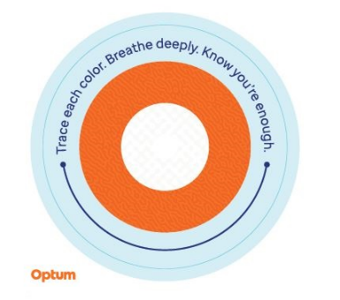

**Trace each color circle:**

Starting on the outer ring and working your way inward, slowly trace each color on the sticker, noticing the changes in texture and breathe deeply. Repeat as many times as necessary.

**4-7-8 breathing:**

Place your finger at the indicated starting point. As you slowly move your finger along the directional line, inhale to a count of 4, then hold your breath for a count of 7 and exhale for a count of 8. Notice the change in texture as you go. Repeat as many times as necessary.

These stickers are recommended to be used as a self-help coping tool for periodic stress and anxious thoughts and are not intended to replace clinical intervention. If you are experiencing persistent stress and/or anxious thoughts and are unable to manage these feelings, consult with a medical or mental health professional for help.

This program should not be used for emergency or urgent care needs. In an emergency, call 911 if you are in the United States, the local emergency

services phone number if you are outside the United States, or go to the nearest A&E. This program is not a substitute for a doctor’s or professional’s

care. Due to the potential for a conflict of interest, legal consultation will not be provided on issues that may involve legal action against Optum or its

affiliates, or any entity through which the caller is receiving these services directly or indirectly (e.g., employer or health plan). This program and all its

components, in particular services to family members below the age of 16, may not be available in all locations and is subject to change without prior

notice. Experience and/or educational levels of Employee Assistance Programme resources may vary based on contract requirements or country

regulatory requirements. Coverage exclusions and limitations may apply.

© 2023 Optum, Inc. All rights reserved. Optum is a registered trademark of Optum, Inc. in the U.S. and other jurisdictions. All other brand or product

names are trademarks or registered marks of the property of their respective owners. Optum is an equal opportunity employer.