Below is suggested social media copy (image options attached) to help you promote this month’s health and wellness topic – Women’s Mental Health – amongst your members. Please feel free to share this on your internal communication platforms and via your own LinkedIn accounts, as appropriate.

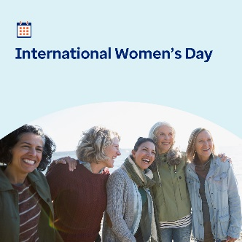  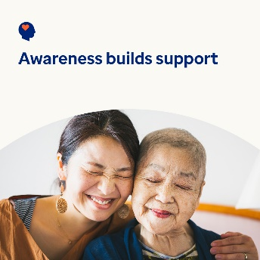 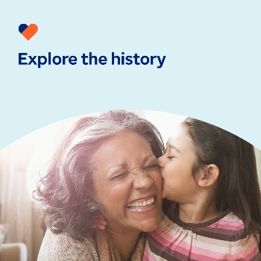

* The 8th of March is International Women’s Day. Check out this month’s toolkit to explore meaningful ways to support women’s mental health and wellbeing, and empower the women in your life and around the world. [optumwellbeing.com/newthismonth/en-GB](https://optumwellbeing.com/newthismonth/en-GB) #employeehealth #wellbeing #AccelerateAction #IWD2025
* Recognising your own value can lead to a more fulfilling life and a greater sense of optimism. Use this worksheet to help yourself appreciate your worth. [optumwellbeing.com/newthismonth/en-GB](https://optumwellbeing.com/newthismonth/en-GB) #employeehealth #wellbeing #AccelerateAction #IWD2025
* Understanding mental health and wellbeing is an important way to support others. Learn how in this month’s toolkit. [optumwellbeing.com/newthismonth/en-GB](https://optumwellbeing.com/newthismonth/en-GB) #employeehealth #wellbeing #AccelerateAction #IWD2025
* Explore the history behind International Women’s Day in this month’s toolkit. [optumwellbeing.com/newthismonth/en-GB](https://optumwellbeing.com/newthismonth/en-GB) #employeehealth #wellbeing #AccelerateAction #IWD2025

**How to post on LinkedIn:**

* Open your LinkedIn account
* Select your preferred text (including link) from above. Copy + Paste.
* Choose your preferred image and add it to your post (save the image to your drive, select ‘Add photo’ prior to step 4)
* Click ‘Post’