Below is suggested social media copy (image options attached) to help you promote this month’s health and wellness topic – women’s mental health – among your members. Please feel free to share this on your internal communication platforms and via your own LinkedIn accounts, as appropriate.

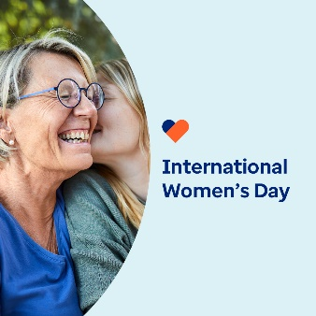 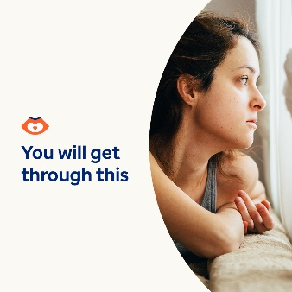 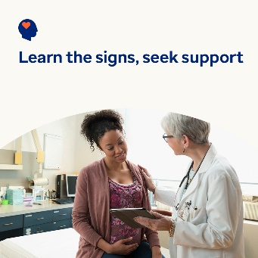 

* 8th March is International Women’s Day. Learn how you can help support the mental health and wellbeing of the women in your life through major life transitions and challenges. [optumwellbeing.com/newthismonth/en-GB](https://optumwellbeing.com/newthismonth/en-GB) #employeehealth #wellbeing #internationalwomensday #IWD2024
* If you’re struggling with infertility, no one can tell you how to feel or what to do. But hopefully, reading this will help you to get through what you’re going through and to feel supported. [optumwellbeing.com/newthismonth/en-GB](https://optumwellbeing.com/newthismonth/en-GB) #employeehealth #wellbeing #internationalwomensday #IWD2024
* Many women around the world who are pregnant or have just given birth experience depression and anxiety — both of which are treatable. Learn about the signs and symptoms, as well as self-help and professional treatment options. [optumwellbeing.com/newthismonth/en-GB](https://optumwellbeing.com/newthismonth/en-GB) #employeehealth #wellbeing #internationalwomensday #IWD2024
* Menopause is a natural part of the natural biological ageing process in women. Yet very few people talk about it. Help get the conversation started — read this quick overview of what to expect during menopause. [optumwellbeing.com/newthismonth/en-GB](https://optumwellbeing.com/newthismonth/en-GB) #employeehealth #wellbeing #internationalwomensday #IWD2024

**How to post on LinkedIn:**

* Open your LinkedIn account.
* Select your preferred text (including link) from above. Copy + Paste.
* Choose your preferred image and add it to your post (save the image to your drive, select ‘Add photo’ prior to step 4).
* Click ‘Post’.