June 2023 Social Media Post Options

Celebrating Differences

Below is suggested social media copy (image options attached) to help you promote this month’s health and wellness topic – Celebrating Diversity – amongst your members. Please feel free to share this on your internal communication platforms and via your own LinkedIn accounts, as appropriate.

  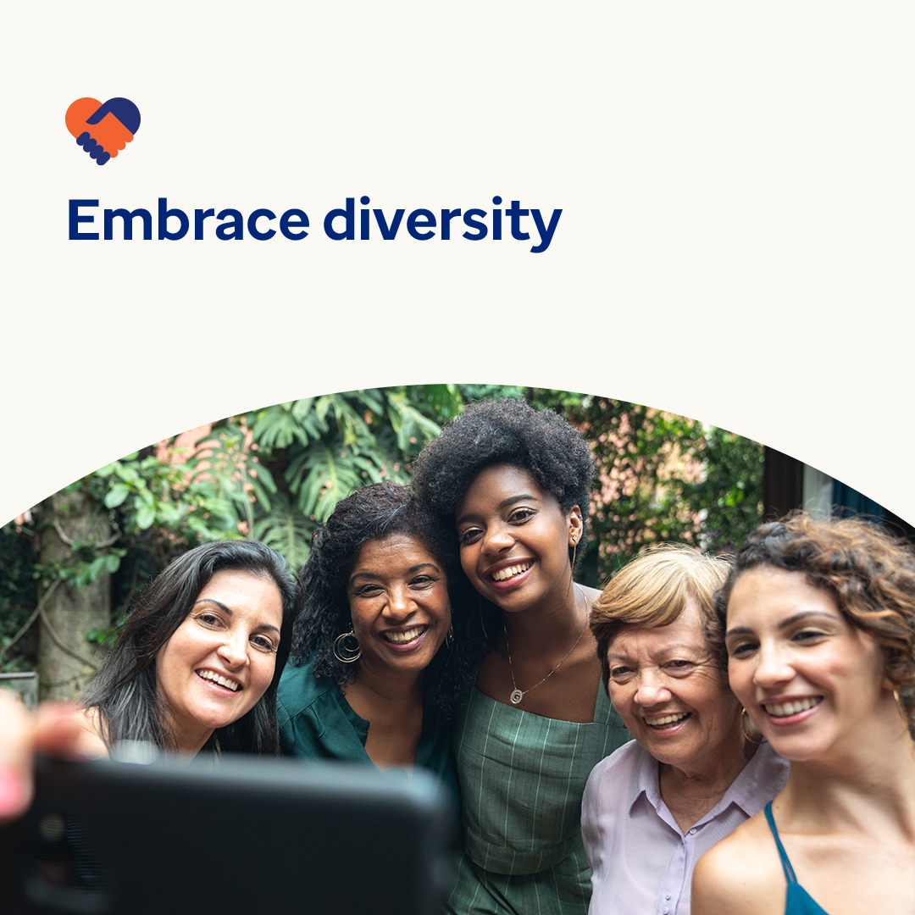

* Most of us want to feel respected, valued and welcomed at home, in our community and at work. So it makes sense that we’d each do our part to help others feel the same way. Have a look at some important ways to do just that. optumeap.com/newthismonth/en-GB #employeehealth #wellbeing
* Are there more ways you can say ‘yes’ to celebrating the value in what makes each person unique? Check out the ‘new this month’ worksheet on optumeap.com/newthismonth/en-GB to learn more about yourself and how you approach people’s differences. #employeehealth #wellbeing
* Supporting diversity is more than just acknowledging people are different from one another – it means recognising the value in these differences and doing what we can to help others feel welcome and accepted. Let’s celebrate our differences this month and every month. optumeap.com/newthismonth/en-GB #employeehealth #wellbeing

**How to post on LinkedIn:**

* Open your LinkedIn account
* Select your preferred text (including link) from above. Copy + Paste
* Choose your preferred image and add it to your post (save the image to your drive, select ‘Add photo’ prior to step 4)
* Click ‘Post’