Below is suggested social media copy (image options attached) to help you promote this month’s health and wellness topic — Celebrating Our Differences — amongst your members. Please feel free to share this on your internal communication platforms and via your own LinkedIn accounts, as appropriate.

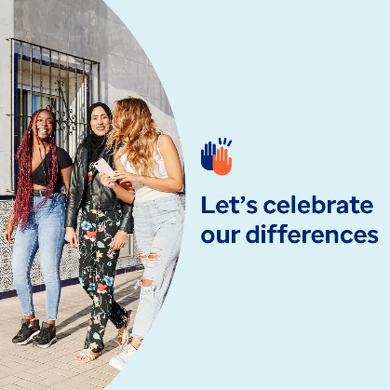  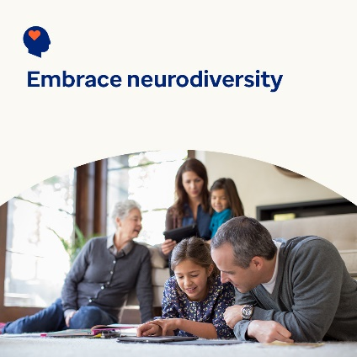

* Diversity brings new ideas and fresh perspectives that benefit our lives, communities and workplaces. This month’s toolkit looks at how to appreciate, value and support what makes each of us unique. [optumwellbeing.com/newthismonth/en-GB](https://optumwellbeing.com/newthismonth/en-GB) #employeehealth #wellbeing
* Everyone has blind spots — it’s part of being human. But they can keep us from understanding ourselves and seeing the value in others. Learn tips for uncovering your blind spots. [optumwellbeing.com/newthismonth/en-GB](https://optumwellbeing.com/newthismonth/en-GB) #employeehealth #wellbeing
* About 10–20% of people are neurodivergent. This means that they think and process information differently to how most people do. Learn more about neurodiversity and the many benefits it offers our world. [optumwellbeing.com/newthismonth/en-GB](https://optumwellbeing.com/newthismonth/en-GB) #employeehealth #wellbeing

**How to post on LinkedIn:**

* Open your LinkedIn account
* Select your preferred text (including link) from above. Copy + Paste
* Choose your preferred image and add it to your post (save the image to your drive, select ‘Add photo’ prior to step 4)
* Click ‘Post’