Below is suggested social media copy (image options attached) to help you promote this month’s health and wellness topic — Celebrating Our Differences — among your members. Feel free to share on your internal communication platforms and via your own LinkedIn accounts, as appropriate.

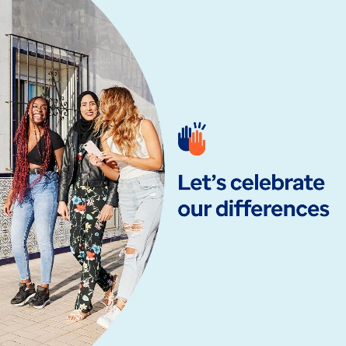  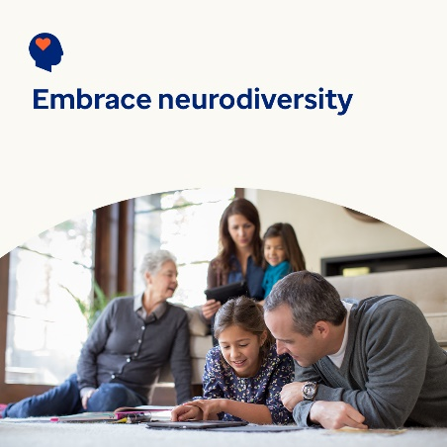

* Diversity brings new ideas and fresh perspectives that benefit our lives, communities and workplaces. This month’s toolkit looks at important ways to appreciate, value and support what makes each of us unique. [optumwellbeing.com/newthismonth/en-US](https://optumwellbeing.com/newthismonth/en-US) #employeehealth #wellbeing
* Everyone has blind spots — it’s part of being human. But they can keep us from understanding ourselves and seeing the value in others. Learn tips for uncovering your blind spots. [optumwellbeing.com/newthismonth/en-US](https://optumwellbeing.com/newthismonth/en-US) #employeehealth #wellbeing
* About 10–20% of people are neurodivergent. That means they think and process information differently from how most people do. Learn more about neurodiversity and the many benefits it offers our world. [optumwellbeing.com/newthismonth/en-US](https://optumwellbeing.com/newthismonth/en-US) #employeehealth #wellbeing

**How to post on LinkedIn:**

* Open your LinkedIn account
* Select your preferred text (including link) from above. Copy + paste
* Choose your preferred image and add to your post (save image to your drive, select “add photo” prior to step 4
* Click “post”