Below is suggested social media copy (image options attached) to help you promote this month’s health and wellness topic – Cultural Awareness – amongst your members. Please feel free to share this on your internal communication platforms and via your own LinkedIn accounts, as appropriate.

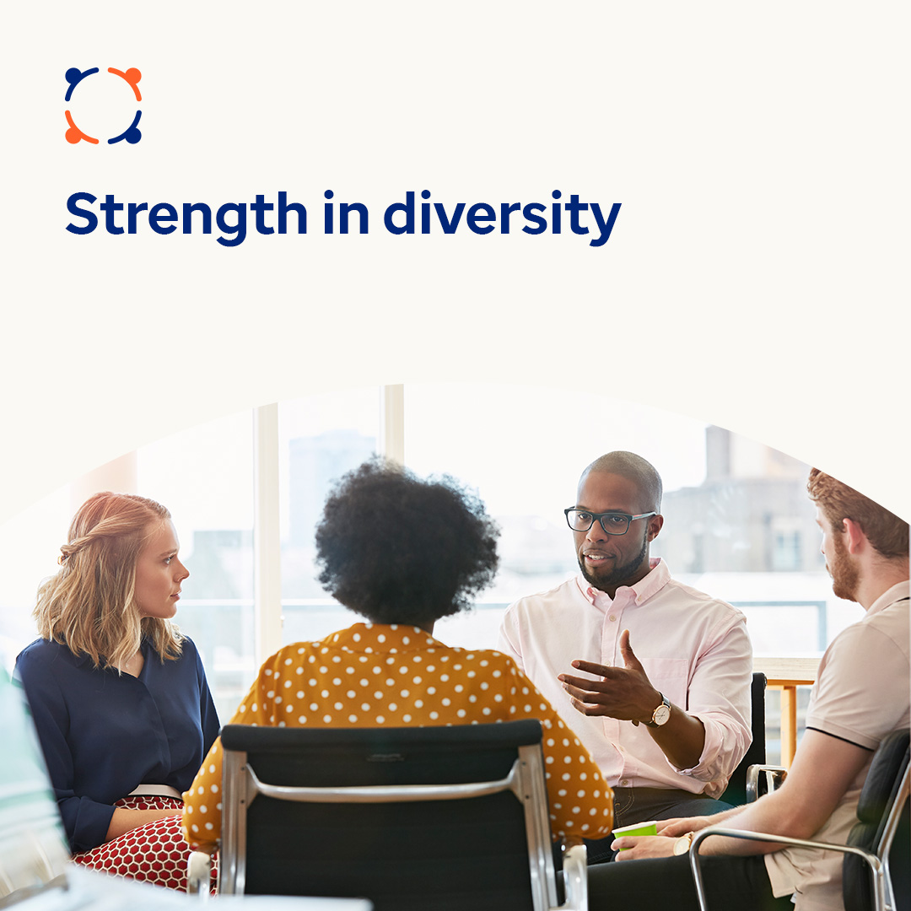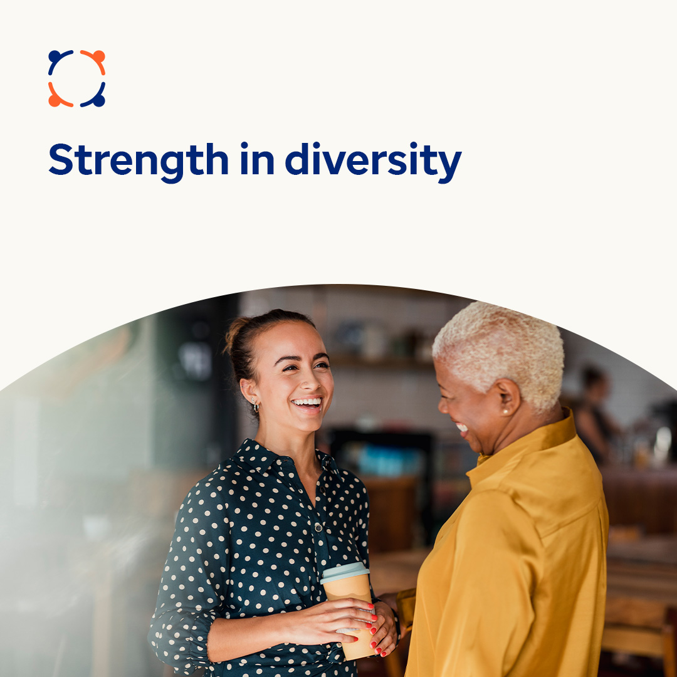

- More people are working and living in multicultural settings. This diversity brings new ideas that benefit our workplaces, communities and the world. But it can also lead to interpersonal misunderstandings. This month, let’s focus on overcoming the challenges and embracing the benefits of multiculturalism. optumwellbeing.com/newthismonth/en-GB
#employeehealth #wellbeing

- Are you in a relationship with someone from a different background? Learn tips for talking about your cultural differences and overcoming misunderstandings. optumwellbeing.com/newthismonth/en-GB #employeehealth #wellbeing

How to post on LinkedIn:
- Open your LinkedIn account
- Select your preferred text (including link) from above. Copy + Paste
- Choose your preferred image and add it to your post (save the image to your drive, select ‘Add photo’ prior to step 4)
- Click ‘Post’

