Below is suggested social media copy (image options attached) to help you promote this month’s health and wellness topic — Anxiety and Panic — among your members. Please feel free to share this on your internal communication platforms and via your own LinkedIn accounts, as appropriate.

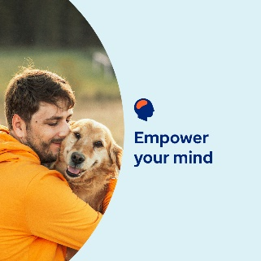   

* This month, we will be sharing resources, tips and tools to help you understand what may be driving your anxious thoughts and feelings — and how to manage them. [optumwellbeing.com/newthismonth/en-GB](https://optumwellbeing.com/newthismonth/en-GB) #employeehealth #wellbeing
* It’s natural to feel worried, nervous and uneasy from time to time, and sometimes it’s even good for you. Learn why and what your anxious thoughts and feelings may be telling you. [optumwellbeing.com/newthismonth/en-GB](https://optumwellbeing.com/newthismonth/en-GB) #employeehealth #wellbeing

* Learn what a panic attack is and what it might feel like, and get tips for getting yourself or someone else through one. [optumwellbeing.com/newthismonth/en-GB](https://optumwellbeing.com/newthismonth/en-GB) #employeehealth #wellbeing
* Racism threatens the health and wellbeing of many people around the world. Learn what race-based trauma is, tools for coping with it and how to find the support you may need to heal from it. [optumwellbeing.com/newthismonth/en-GB](https://optumwellbeing.com/newthismonth/en-GB) #employeehealth #wellbeing

**How to post on LinkedIn:**

* Open your LinkedIn account
* Select your preferred text (including link) from above. Copy + Paste
* Choose your preferred image and add it to your post (save the image to your drive, select ‘Add photo’ prior to step 4)
* Click ‘Post’