Below is suggested social media copy (image options attached) to help you promote this month’s health and wellness topic – Mind-body wellness connection – among your members. Feel free to share on your internal communication platforms and via your own LinkedIn accounts, as appropriate.

  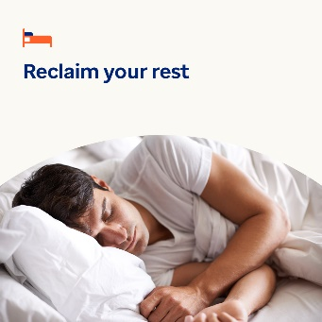 

[Image 1](https://www.optum.com/content/dam/o4-dam/images/consumers/health-solutions/find-calm-through-routine-jan25.jpg?appId=aemshell) [Image 2](https://www.optum.com/content/dam/o4-dam/images/consumers/health-solutions/moments-of-comfort-jan25.jpg?appId=aemshell) [Image 3](https://www.optum.com/content/dam/o4-dam/images/consumers/health-solutions/reclaim-your-rest-jan25.jpg?appId=aemshell) [Image 4](https://www.optum.com/content/dam/o4-dam/images/consumers/health-solutions/find-new-momentum-jan25.jpg?appId=aemshell)

* While you can’t control every aspect of life, creating a routine can benefit your mental health and wellbeing. Use this guide and worksheet to build a routine that’s easy to stick to. [optumwellbeing.com/newthismonth/en-US](https://www.optumwellbeing.com/newthismonth/en-US) #employeehealth #wellbeing
* Do you know what “glimmers” are? They’re moments you can practice capturing to feel more joy and comfort in your life. Learn more in this month’s toolkit. [optumwellbeing.com/newthismonth/en-US](https://www.optumwellbeing.com/newthismonth/en-US) #employeehealth #wellbeing
* About one-third of adults globally do not get enough quality sleep. Use this interactive worksheet to create a sleep plan. Then challenge yourself to sleep better in January and beyond. [optumwellbeing.com/newthismonth/en-US](https://www.optumwellbeing.com/newthismonth/en-US) #employeehealth #wellbeing
* Feeling “stuck” in your professional, personal or emotional life? Here are some tips to help you get “unstuck” and reset. [optumwellbeing.com/newthismonth/en-US](https://www.optumwellbeing.com/newthismonth/en-US) #employeehealth #wellbeing

**How to post on LinkedIn:**

* Open your LinkedIn account
* Select your preferred text (including link) from above. Copy + paste
* Choose your preferred image and add to your post (save image to your drive, select “add photo” prior to step 4
* Click “post”