Below is suggested social media copy (image options attached) to help you promote this month’s health and wellness topic – Mind-body wellness connection – amongst your members. Please feel free to share this on your internal communication platforms and via your own LinkedIn accounts, as appropriate.

  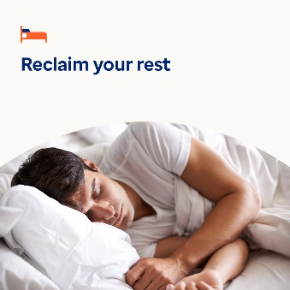 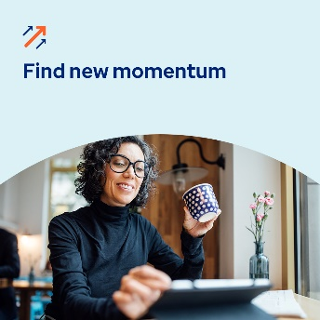

* While you can’t control every aspect of life, creating a routine can benefit your mental health and wellbeing. Use this guide and worksheet to build a routine that’s easy to stick to. [optumwellbeing.com/newthismonth/en-GB](https://optumwellbeing.com/newthismonth/en-GB) #employeehealth #wellbeing
* Do you know what ‘glimmers’ are? They’re moments you can practise capturing to feel more joy and comfort in your life. Learn more in this month’s toolkit. [optumwellbeing.com/newthismonth/en-GB](https://optumwellbeing.com/newthismonth/en-GB) #employeehealth #wellbeing
* About one third of adults globally do not get enough quality sleep. Use this interactive worksheet to create a sleep plan. Then challenge yourself to sleep better in January and beyond. [optumwellbeing.com/newthismonth/en-GB](https://optumwellbeing.com/newthismonth/en-GB) #employeehealth #wellbeing
* Feeling ‘stuck’ in your professional, personal or emotional life? Here are some tips to help you get ‘unstuck’ and reset. [optumwellbeing.com/newthismonth/en-GB](https://optumwellbeing.com/newthismonth/en-GB) #employeehealth #wellbeing

**How to post on LinkedIn:**

* Open your LinkedIn account
* Select your preferred text (including link) from above. Copy + Paste
* Choose your preferred image and add it to your post (save the image to your drive, select ‘Add photo’ prior to step 4)
* Click ‘Post’