Below is suggested social media copy (image options attached) to help you promote this month’s health and wellness topic – Mind-Body Connection – amongst your members. Please feel free to share this on your internal communication platforms and via your own LinkedIn accounts, as appropriate.

  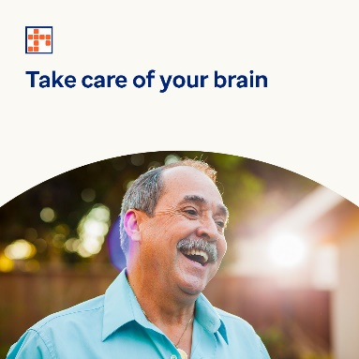

* Learn how nurturing your brain and improving your self-worth can help alleviate symptoms and prevent mental health concerns. Learn more in this month’s toolkit. [optumwellbeing.com/newthismonth/en-GB](https://optumwellbeing.com/newthismonth/en-GB) #employeehealth #wellbeing
* The foods and drinks you consume can boost your brain function, promote healthy digestion and improve your overall emotional and mental state. Get tips on what to eat to support your mental health and wellbeing. [optumwellbeing.com/newthismonth/en-GB](https://optumwellbeing.com/newthismonth/en-GB) #employeehealth #wellbeing
* Do you value yourself as much as you should? Learn why self-worth and self-esteem are so important, and how to gain a more positive self-perspective. [optumwellbeing.com/newthismonth/en-GB](https://optumwellbeing.com/newthismonth/en-GB) #employeehealth #wellbeing

* Learn 6 simple ways to keep your brain healthy as you age! [optumwellbeing.com/newthismonth/en-GB](https://optumwellbeing.com/newthismonth/en-GB) #employeehealth #wellbeing

**How to post on LinkedIn:**

1. Open your LinkedIn account
2. Select your preferred text (including link) from above. Copy + Paste
3. Choose your preferred image and add it to your post (save the image to your drive, select ‘Add photo’ prior to step 4)
4. Click ‘Post’