Below is suggested social media copy (image options attached) to help you promote this month’s health and wellness topic — Food and mental health — among your members. Feel free to share on your internal communication platforms and via your own LinkedIn accounts, as appropriate.

  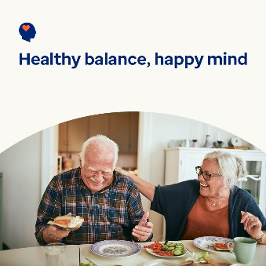 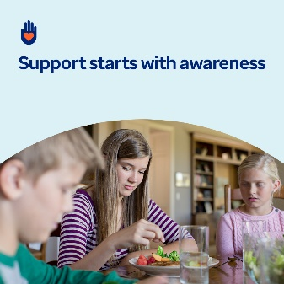

[Image 1](https://www.optum.com/content/dam/o4-dam/images/consumers/health-solutions/healthy-food-health-mind-feb25.jpg?appId=aemshell) [Image 2](https://www.optum.com/content/dam/o4-dam/images/consumers/health-solutions/hope-grows-with-support-feb25.jpg?appId=aemshell) [Image 3](https://www.optum.com/content/dam/o4-dam/images/consumers/health-solutions/healthy-balance-happy-mind-feb25.jpg?appId=aemshell) [Image 4](https://www.optum.com/content/dam/o4-dam/images/consumers/health-solutions/support-starts-with-awareness-feb25.jpg?appId=aemshell)

* The connection between food and mental health plays a critical role in wellbeing. This month, explore resources to help foster positive relationships with food and support overall health and wellness. In honor of World Cancer Day, find additional resources to support individuals and caregivers navigating cancer. [optumwellbeing.com/newthismonth/en-US](https://www.optumwellbeing.com/newthismonth/en-US) #employeehealth #wellbeing #WorldCancerDay
* February 4 is World Cancer Day. In this month’s toolkit, learn how to offer support and understanding for the emotional challenges individuals diagnosed with cancer and their loved ones may face. [optumwellbeing.com/newthismonth/en-US](https://www.optumwellbeing.com/newthismonth/en-US) #employeehealth #wellbeing #WorldCancerDay
* Do you have a healthy relationship with food? Learn the signs to watch for and how to take an “all-foods-fit” approach to nourish your body and mind in this month’s toolkit. [optumwellbeing.com/newthismonth/en-US](https://www.optumwellbeing.com/newthismonth/en-US) #employeehealth #wellbeing
* Are you concerned someone you care about is struggling with an eating disorder? Learn the signs and symptoms of eating disorders and disordered eating in this month’s toolkit. [optumwellbeing.com/newthismonth/en-US](https://www.optumwellbeing.com/newthismonth/en-US) #employeehealth #wellbeing

**How to post on LinkedIn:**

* Open your LinkedIn account.
* Select your preferred text (including link) from above. Copy + paste.
* Choose your preferred image and add to your post (save image to your drive, select “add photo” prior to step 4).
* Click “post”.