Below is suggested social media copy (image options attached) to help you promote this month’s health and wellness topic – Food and mental health – among your members. Please feel free to share this on your internal communication platforms and via your own LinkedIn accounts, as appropriate.

 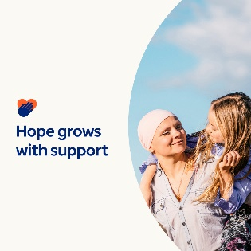 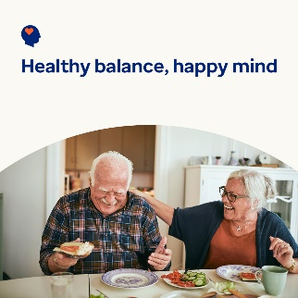 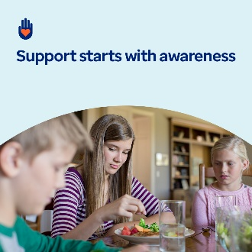

* The connection between food and mental health plays a critical role in wellbeing. This month, explore resources to help foster positive relationships with food and support overall health and wellness. In honour of World Cancer Day, you can also find additional resources on supporting individuals and caregivers navigating cancer. [optumwellbeing.com/newthismonth/en-GB](https://optumwellbeing.com/newthismonth/en-GB) #employeehealth #wellbeing #WorldCancerDay
* The 4th February is World Cancer Day. In this month’s toolkit, learn how to offer support and understanding during the emotional challenges individuals diagnosed with cancer and their loved ones may face. [optumwellbeing.com/newthismonth/en-GB](https://optumwellbeing.com/newthismonth/en-GB) #employeehealth #wellbeing #WorldCancerDay
* Do you have a healthy relationship with food? Learn the signs to watch for and how to take an ‘all-foods-fit’ approach to nourish your body and mind in this month’s toolkit. [optumwellbeing.com/newthismonth/en-GB](https://optumwellbeing.com/newthismonth/en-GB) #employeehealth #wellbeing
* Are you worried that someone you care about is struggling with an eating disorder? Learn the signs and symptoms of eating disorders and disordered eating in this month’s toolkit. [optumwellbeing.com/newthismonth/en-GB](https://optumwellbeing.com/newthismonth/en-GB) #employeehealth #wellbeing

**How to post on LinkedIn:**

* Open your LinkedIn account.
* Select your preferred text (including link) from above. Copy + Paste.
* Choose your preferred image and add it to your post (save the image to your drive, select ‘Add photo’ prior to step 4).
* Click ‘Post’.