Below is suggested social media copy (image options attached) to help you promote this month’s health and wellness topic – Food and mental health – among your members. Please feel free to share this on your internal communication platforms and via your own LinkedIn accounts, as appropriate.

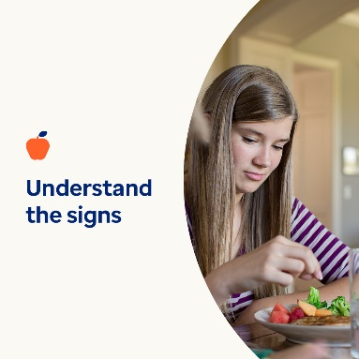 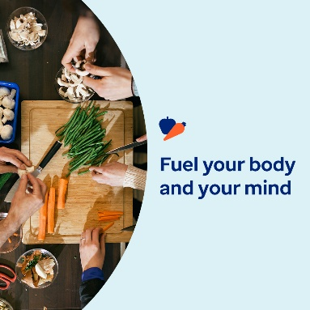 

* A healthy relationship with food fuels your physical, emotional and mental wellbeing. Assess your relationship with food by answering a few questions. Learn some self-help steps for improving it. [optumwellbeing.com/newthismonth/en-GB](https://optumwellbeing.com/newthismonth/en-GB) #employeehealth #wellbeing
* Are you worried that you, or someone you care about, is struggling with an eating disorder? Use this interactive screening tool to understand the signs and symptoms better. [optumwellbeing.com/newthismonth/en-GB](https://optumwellbeing.com/newthismonth/en-GB) #employeehealth #wellbeing
* Taking care of your mind is just as important as taking care of your body. Learn how to protect your mental and emotional wellbeing, and give them a boost in difficult times. [optumwellbeing.com/newthismonth/en-GB](https://optumwellbeing.com/newthismonth/en-GB) #employeehealth #wellbeing

**How to post on LinkedIn:**

* Open your LinkedIn account.
* Select your preferred text (including link) from above. Copy + Paste.
* Choose your preferred image and add it to your post (save the image to your drive, select ‘Add photo’ prior to step 4).
* Click ‘Post’.