Below is suggested social media copy (image options attached) to help you promote this month’s health and wellness topic — Food and mental health — among your members. Feel free to share on your internal communication platforms and via your own LinkedIn accounts, as appropriate.

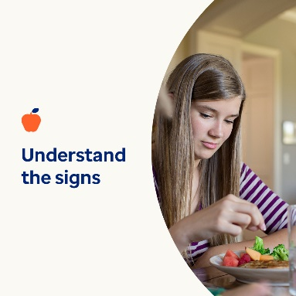 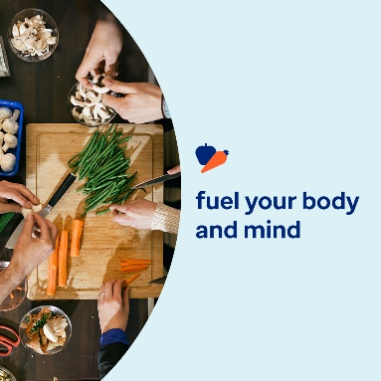 

* A healthy relationship with food fuels your physical, emotional and mental wellbeing. Answer a few questions to assess your relationship with food. Learn self-help steps to improve it. [optumwellbeing.com/newthismonth/en-US](https://optumwellbeing.com/newthismonth/en-US) #employeehealth #wellbeing
* Are you concerned you or someone you care about is struggling with an eating disorder? Use this interactive screening tool to better understand the signs and symptoms. [optumwellbeing.com/newthismonth/en-US](https://optumwellbeing.com/newthismonth/en-US) #employeehealth #wellbeing
* Taking care of your mind is just as important as taking care of your body. Learn ways to protect your mental and emotional well-being, and give them a boost in difficult times. [optumwellbeing.com/newthismonth/en-US](https://optumwellbeing.com/newthismonth/en-US) #employeehealth #wellbeing

**How to post on LinkedIn:**

* Open your LinkedIn account.
* Select your preferred text (including link) from above. Copy + paste.
* Choose your preferred image and add to your post (save image to your drive, select “Add photo” prior to step 4.
* Click “Post”.