Below is suggested social media copy (image options attached) to help you promote this month’s health and wellness topic – Stress and Anxiety – amongst your members. Please feel free to share this on your internal communication platforms and via your own LinkedIn accounts, as appropriate.

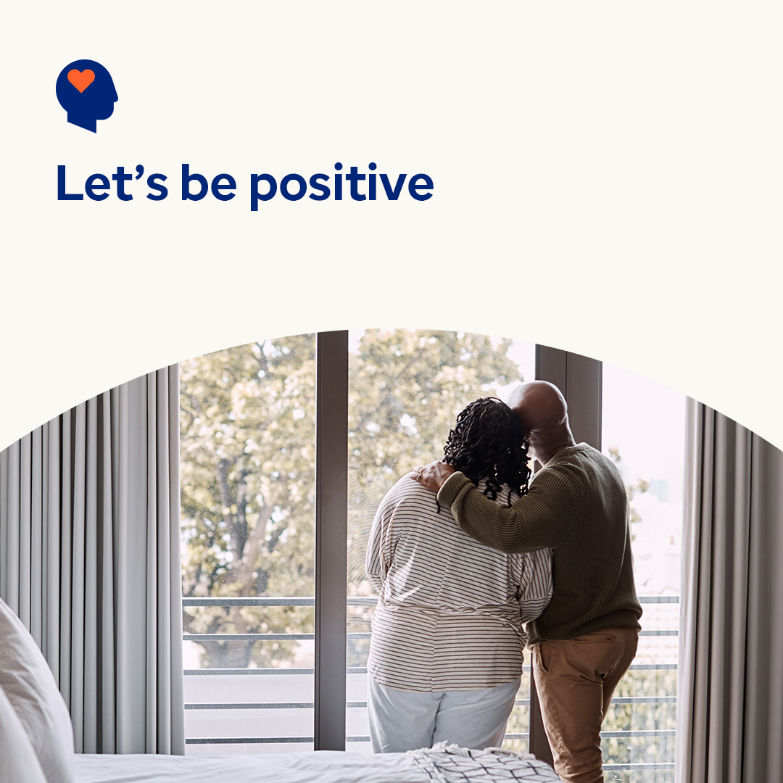  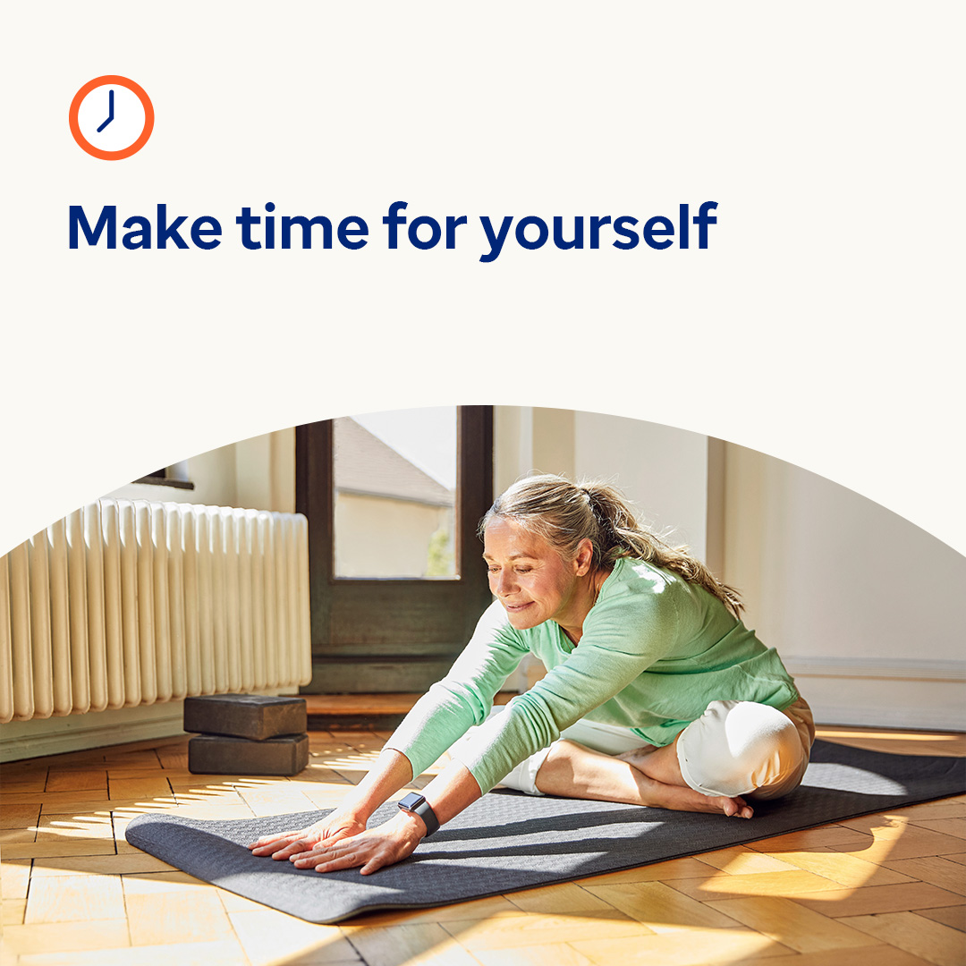

* Learn tips for observing unhelpful thoughts and reframing them to be more positive, so you can get through tough times more easily. [optumwellbeing.com/newthismonth/en-GB](https://optumwellbeing.com/newthismonth/en-GB) #employeehealth #wellbeing
* Most of us feel pressed for time – even an extra 15 minutes here and there could make a difference. Use this worksheet to help streamline your important tasks so that you can simplify your life. [optumwellbeing.com/newthismonth/en-GB](https://optumwellbeing.com/newthismonth/en-GB) #employeehealth #wellbeing
* Looking for some ideas on how to give yourself a break? Watch this video. [optumwellbeing.com/newthismonth/en-GB](https://optumwellbeing.com/newthismonth/en-GB) #employeehealth #wellbeing

**How to post on LinkedIn:**

* Open your LinkedIn account
* Select your preferred text (including link) from above. Copy + Paste
* Choose your preferred image and add it to your post (save the image to your drive, select ‘Add photo’ prior to step 4)
* Click ‘Post’