Below is suggested social media copy (image options attached) to help you promote this month’s health and wellness topic – Youth Mental Health – amongst your members. Please feel free to share this on your internal communication platforms and via your own LinkedIn accounts, as appropriate.

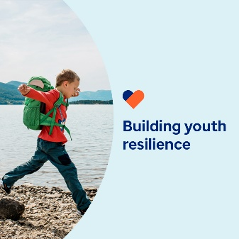 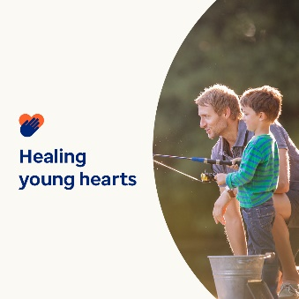 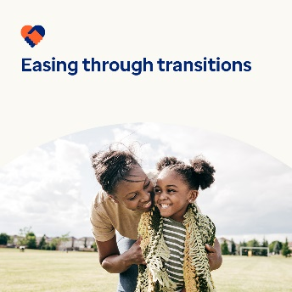 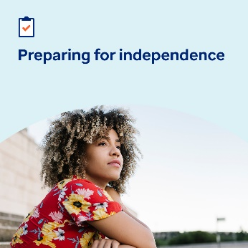

* Life brings many challenges. This month’s toolkit offers ways to help young people build resilience, manage major transitions and cope with traumatic life events. [optumwellbeing.com/newthismonth/en-GB](https://optumwellbeing.com/newthismonth/en-GB) #employeehealth #wellbeing
* When a child in your care goes through or witnesses a traumatic life event, it can be hard to know what to do or how to help them. Here are some suggestions on where to start. [optumwellbeing.com/newthismonth/en-GB](https://optumwellbeing.com/newthismonth/en-GB) #employeehealth #wellbeing
* Get tips for caregivers on how to help children and adolescents get through the stress of big transitions, like the start of a new school year, in this month’s toolkit. [optumwellbeing.com/newthismonth/en-GB](https://optumwellbeing.com/newthismonth/en-GB) #employeehealth #wellbeing
* Is an adolescent in your life getting ready to be on their own? Here’s a tip sheet to help them prepare. [optumwellbeing.com/newthismonth/en-GB](https://optumwellbeing.com/newthismonth/en-GB) #employeehealth #wellbeing

**How to post on LinkedIn:**

* Open your LinkedIn account
* Select your preferred text (including link) from above. Copy + Paste.
* Choose your preferred image and add it to your post (save the image to your drive, select ‘Add photo’ prior to step 4)
* Click ‘Post’