Below is suggested social media copy (image options attached) to help you promote this month’s health and wellness topic — Youth Mental Health — among your members. Feel free to share on your internal communication platforms and via your own LinkedIn accounts, as appropriate.

   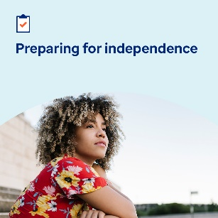

[Image 1 Link](https://www.optum.com/content/dam/o4-dam/images/consumers/health-solutions/building-youth-resilience-social-post-august-2024.jpg) [Image 2 Link](https://www.optum.com/content/dam/o4-dam/images/consumers/health-solutions/healing-young-hearts-social-post-august-2024.jpg) [Image 3 Link](https://www.optum.com/content/dam/o4-dam/images/consumers/health-solutions/easing-through-transitions-social-post-august-2024.jpg) [Image 4 Link](https://www.optum.com/content/dam/o4-dam/images/consumers/health-solutions/preparing-for-independence-social-post-august-2024.jpg)

* Life brings many challenges. This month’s toolkit offers ways to help young people build resilience, manage major transitions and cope with traumatic life events. [optumwellbeing.com/newthismonth/en-US](https://www.optumwellbeing.com/newthismonth/en-US) #employeehealth #wellbeing
* When a child in your care goes through or witnesses a traumatic life event, it can be hard to know what to do or how to help them. Here are some suggestions on where to start. [optumwellbeing.com/newthismonth/en-US](https://www.optumwellbeing.com/newthismonth/en-US) #employeehealth #wellbeing
* Get tips for caregivers on how to help children and adolescents get through the stress of big transitions, like the start of a new school year, in this month’s toolkit. [optumwellbeing.com/newthismonth/en-US](https://www.optumwellbeing.com/newthismonth/en-US) #employeehealth #wellbeing
* Is an adolescent in your life getting ready to be on their own? Here’s a tip sheet to help them prepare. [optumwellbeing.com/newthismonth/en-US](https://www.optumwellbeing.com/newthismonth/en-US) #employeehealth #wellbeing

**How to post on LinkedIn:**

* Open your LinkedIn account
* Select your preferred text (including link) from above. Copy + paste.
* Choose your preferred image and add to your post (save image to your drive; select “add photo” prior to step 4)
* Click “post”