Below is suggested social media copy (image options attached) to help you promote this month’s health and wellness topic – Youth Mental Health – amongst your members. Please feel free to share this on your internal communication platforms and via your own LinkedIn accounts, as appropriate.

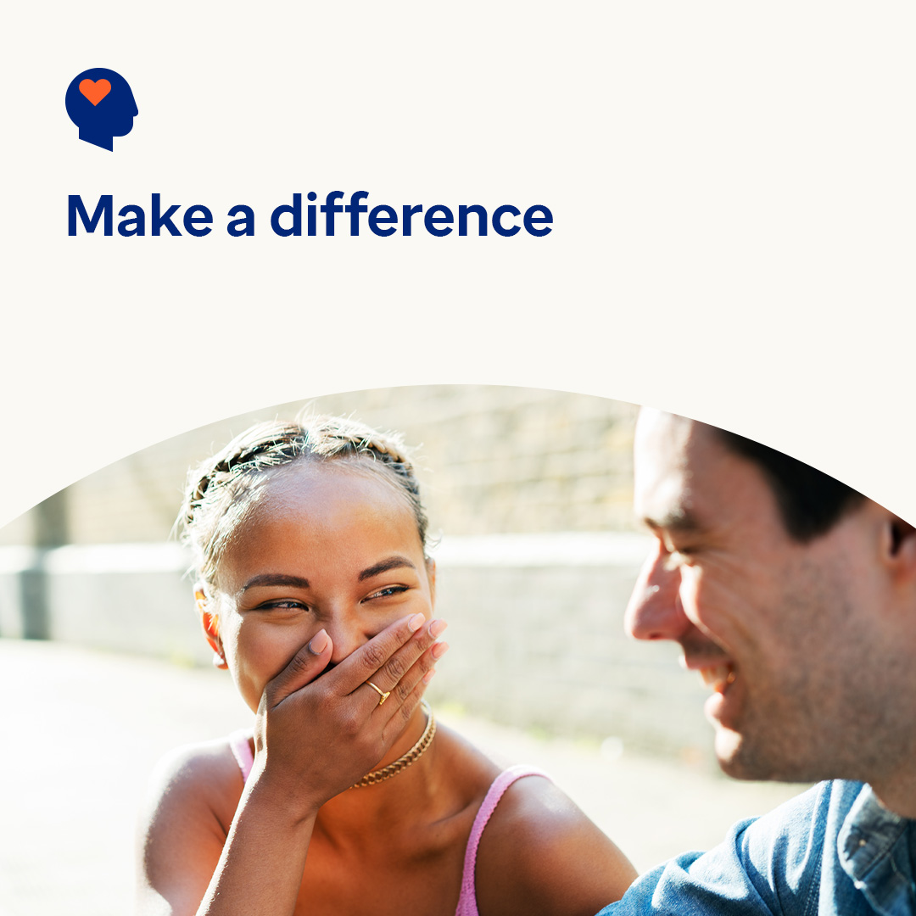 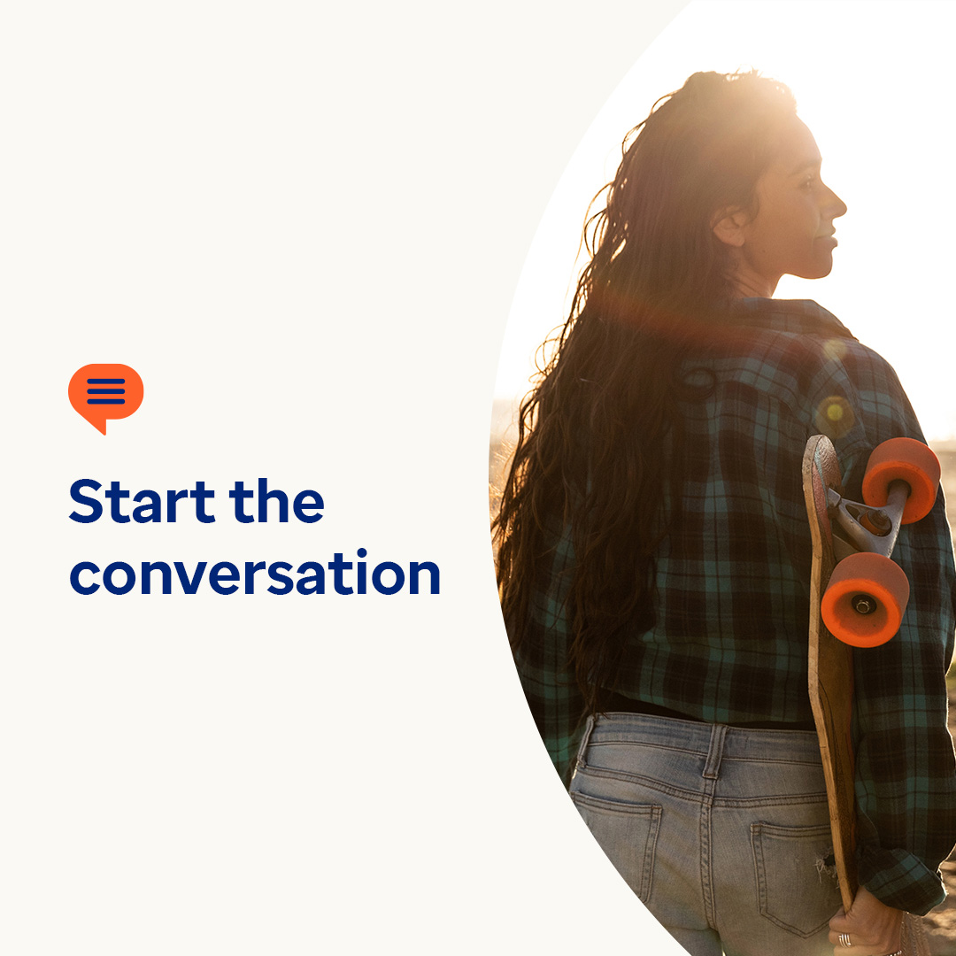 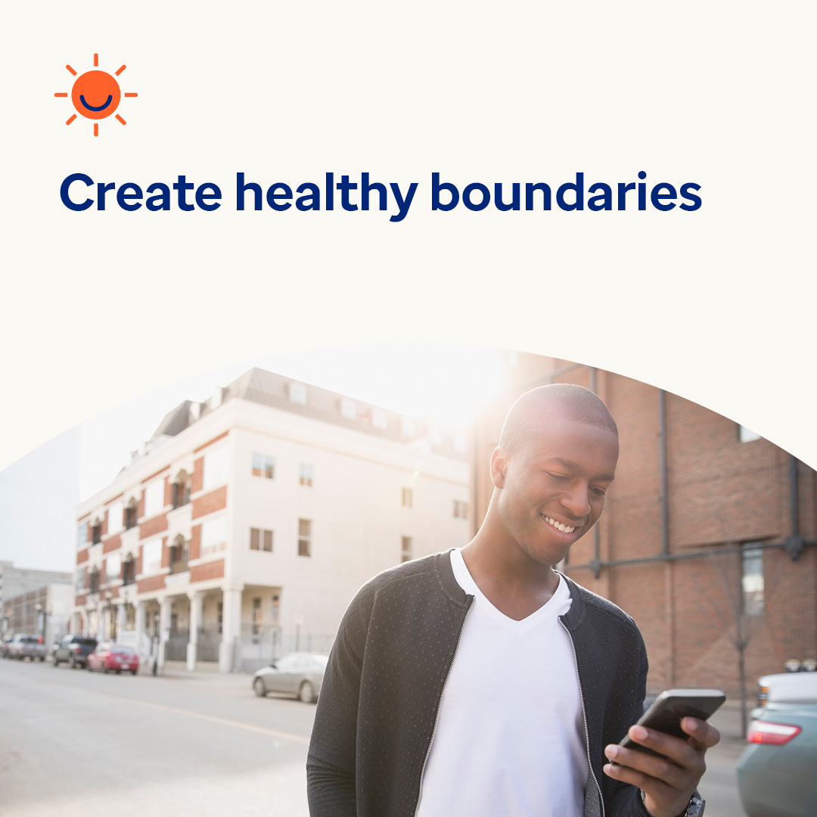

* Many young people around the world are facing mental health concerns. Research shows that when they feel seen, heard and validated, they’re more likely to trust someone to help them. This month, let’s explore ways to help them cope in the moment and get the support they may need. optumwellbeing.com/newthismonth/en-GB #employeehealth #wellbeing
* Are you worried that an adolescent in your life is struggling to find the right words to talk to you about their mental wellbeing? Share this conversation starter guide with them – it’s written for young people. optumwellbeing.com/newthismonth/en-GB #employeehealth #wellbeing
* Looking for ways to clear your mind and set social media boundaries? Check out this month’s tips. optumwellbeing.com/newthismonth/en-GB #employeehealth #wellbeing

**How to post on LinkedIn:**

* Open your LinkedIn account
* Select your preferred text (including link) from above. Copy + Paste
* Choose your preferred image and add it to your post (save the image to your drive, select ‘Add photo’ prior to step 4)
* Click ‘Post’