Below is suggested social media copy (image options attached) to help you promote this month’s health and wellness topic – Youth Mental Health – among your members. Feel free to share on your internal communication platforms and via your own LinkedInaccounts, as appropriate.

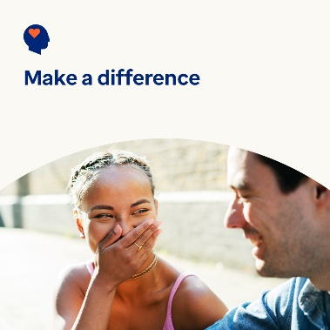 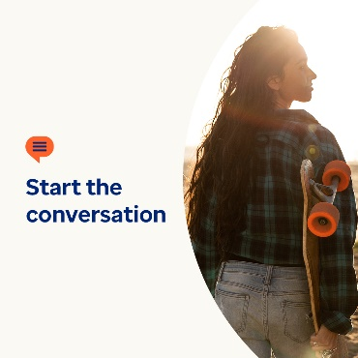 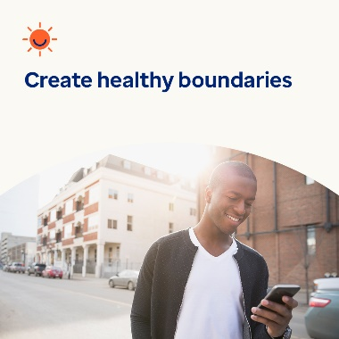

* Many youth around the world are facing mental health concerns. Research shows, when they feel seen, heard and validated, they’re more likely to trust someone to help them. This month, let’s explore ways to help them cope in the moment and get the support they may need. optumwellbeing.com/newthismonth #employeehealth #wellbeing
* Are you concerned an adolescent in your life is struggling to find the right words to talk to you about their mental well-being? Share this conversation starter guide with them – it’s written for youth. optumwellbeing.com/newthismonth #employeehealth #wellbeing
* Looking for ways to clear your mind and set social media boundaries? Check out this month’s tips. optumwellbeing.com/newthismonth #employeehealth #wellbeing

**How to post on LinkedIn:**

* Open your LinkedIn account
* Select your preferred text (including link) from above. Copy + paste
* Choose your preferred image and add to your post (save image to your drive, select “add photo” prior to step 4
* Click “post”