Below is suggested social media copy (image options attached) to help you promote this month’s health and wellness topic – Managing stress, anxiety and panic – amongst your members. Please feel free to share this on your internal communication platforms and via your own LinkedIn accounts, as appropriate.

   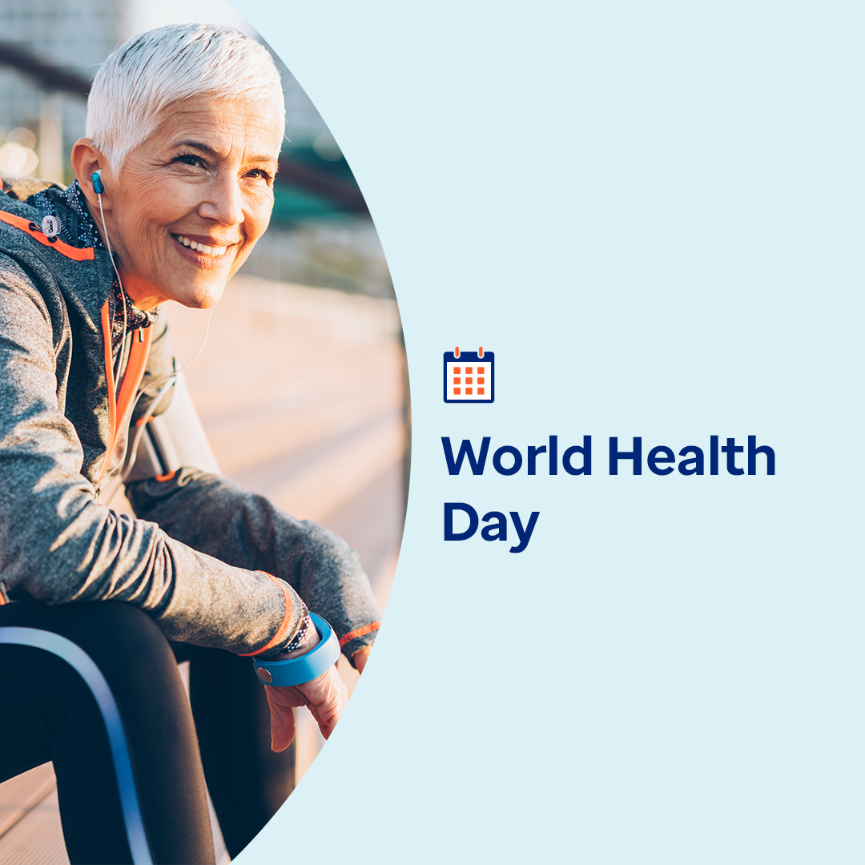

* 7th April is World Health Day. This month, discover proven, practical and fun ways to relieve stress, ease your mind and nurture calm. [optumwellbeing.com/newthismonth/en-GB](https://optumwellbeing.com/newthismonth/en-GB) #employeehealth #wellbeing #WorldHealthDay2025
* Looking for enjoyable ways to find calm? This month’s toolkit offers breathing, music and colouring exercises to help you. [optumwellbeing.com/newthismonth/en-GB](https://optumwellbeing.com/newthismonth/en-GB) #employeehealth #wellbeing #WorldHealthDay2025
* Explore how to control what you can, nurture positivity and build resilience to help manage stress in this month’s toolkit. [optumwellbeing.com/newthismonth/en-GB](https://optumwellbeing.com/newthismonth/en-GB) #employeehealth #wellbeing #WorldHealthDay2025
* Discover the history of World Health Day and how you can help shape its future and carry its ‘health for all’ mission forwards. [optumwellbeing.com/newthismonth/en-GB](https://optumwellbeing.com/newthismonth/en-GB) #employeehealth #wellbeing #WorldHealthDay2025

**How to post on LinkedIn:**

* Open your LinkedIn account.
* Select your preferred text (including link) from above. Copy + Paste.
* Choose your preferred image and add it to your post (save the image to your drive, select ‘Add photo’ prior to step 4).
* Click ‘Post’.