Below is suggested social media copy (image options attached) to help you promote this month’s health and wellness topic – Managing Stress – among your members. Please feel free to share this on your internal communication platforms and via your own LinkedIn accounts, as appropriate.

 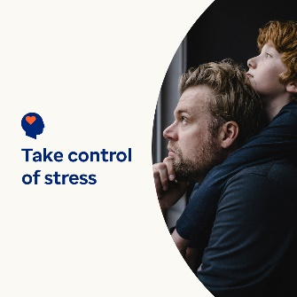  

* 7th April is World Health Day. Have a look at these self-help tips for managing stress and protecting your health and wellbeing. [optumwellbeing.com/newthismonth/en-GB](https://optumwellbeing.com/newthismonth/en-GB) #employeehealth #wellbeing #worldhealthday
* Stress is natural, but you can take more control over how much it affects your life. This article offers practical approaches for taking some of the pressure off yourself. [optumwellbeing.com/newthismonth/en-GB](https://optumwellbeing.com/newthismonth/en-GB) #employeehealth #wellbeing #worldhealthday
* Looking for a fun way to reduce stress? Make your own sensory playtime fun! Here’s a simple recipe for playdough which uses common ingredients. [optumwellbeing.com/newthismonth/en-GB](https://optumwellbeing.com/newthismonth/en-GB) #employeehealth #wellbeing #worldhealthday
* It’s a fact: Pets can make your life better. Learn how as well as how to determine whether getting a pet is right for you. [optumwellbeing.com/newthismonth/en-GB](https://optumwellbeing.com/newthismonth/en-GB) #employeehealth #wellbeing #worldhealthday

**How to post on LinkedIn:**

* Open your LinkedIn account.
* Select your preferred text (including link) from above. Copy + Paste.
* Choose your preferred image and add it to your post (save the image to your drive, select ‘Add photo’ before the next step).
* Click ‘Post’.