Below is suggested social media copy (image options attached) to help you promote this month’s health and wellness topic — Managing stress — among your members. Feel free to share on your internal communication platforms and on your own LinkedIn accounts, as appropriate.

 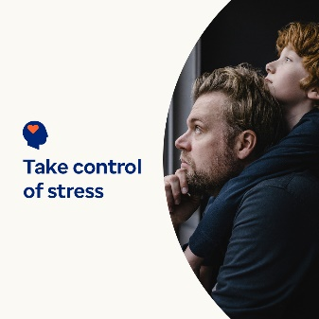  

* April 7 is World Health Day. Check out these self-help tips for managing stress and protecting your health and wellbeing. [optumwellbeing.com/newthismonth/en-US](https://optumwellbeing.com/newthismonth/en-US) #employeehealth #wellbeing #worldhealthday
* Stress is a natural part of living, but you can take more control over how much it affects your life. This article offers practical approaches for taking some of the pressure off yourself. [optumwellbeing.com/newthismonth/en-US](https://optumwellbeing.com/newthismonth/en-US) #employeehealth #wellbeing #worldhealthday
* Looking for a fun way to reduce stress? Make your own sensory playtime fun! Here’s a simple recipe for playdough, using common ingredients. [optumwellbeing.com/newthismonth/en-US](https://optumwellbeing.com/newthismonth/en-US) #employeehealth #wellbeing #worldhealthday
* It’s a fact: Pets can make your life better. Learn how, and how to consider if getting a pet is right for you. [optumwellbeing.com/newthismonth/en-US](https://optumwellbeing.com/newthismonth/en-US) #employeehealth #wellbeing #worldhealthday

**How to post on LinkedIn:**

* Open your LinkedIn account.
* Select your preferred text (including link) from above. Copy + paste.
* Choose your preferred image and add to your post (save image to your drive, select “add photo” before the next step).
* Click “post.”