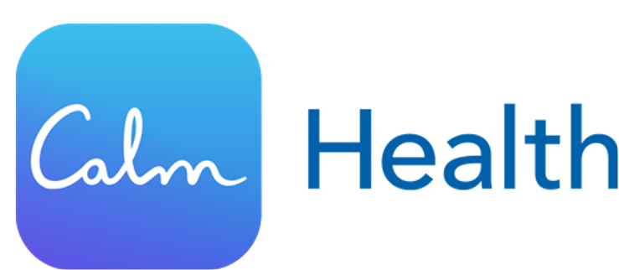

Find your path to a happier, healthier you
You may have heard about or even used the Calm app. Now you have access to its most popular features and much more with Calm Health. Available through your behavioral health benefits at no additional cost, it's packed with curated content tailored to your needs including:
- Programs offering mental health guidance and compassionate support for a wide range of health and wellbeing goals to support your mind and body

- Self-care courses and tools such as getting better sleep to start your days refreshed, building skills to help with stress and anxiety, and developing resiliency to navigate life's uncertainties

- With short screenings, you can understand where you are in your journey and get a more personalized experience to include recommendations for additional solutions and services from your health plan, such as coaching or therapy

Scan the QR code below or follow this link to create an account and register for the Calm Health app. When prompted, provide your first name, last name, date of birth and Member ID.


